# Section 1: Let's Dive In!

## How to Get Help

## Join Our Community!

## Course Resources

## Let's Build an App!

## Critical Questions

## Quiz 1: Core Concepts

## A Few More Critical Questions

## Node Setup

npx create-react-app <project name>

npx create-react-app jsx

cd jsx

npm start

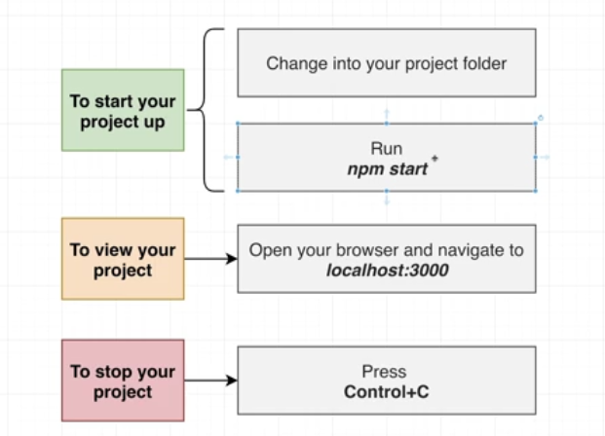

## What is Create React App?

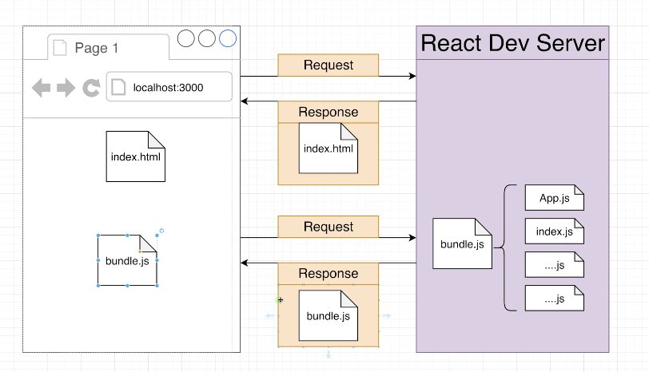 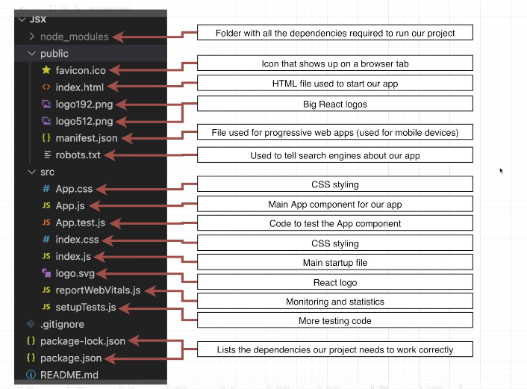 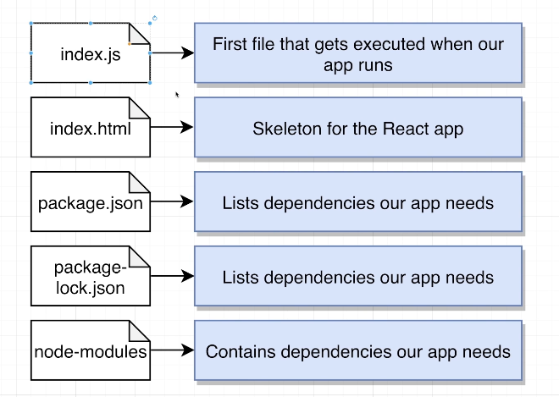

# Section 2: Creating Content with JSX

## Showing Basic Content

// 1) Import the React and ReactDOM libraries

import React from 'react';

import ReactDOM from 'react-dom/client';

// 2) Get a reference to the div with ID root

const el = document.getElementById('root');

// 3) Tell React to take control of that element

const root = ReactDOM.createRoot(el);

// 4) Create a component

function App() {

  return <h1>Hi there!</h1>;

}

// 5) Show the component on the screen

root.render(<App />);

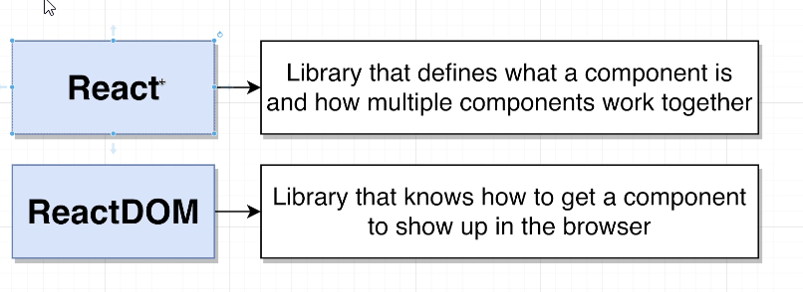

## What is JSX?

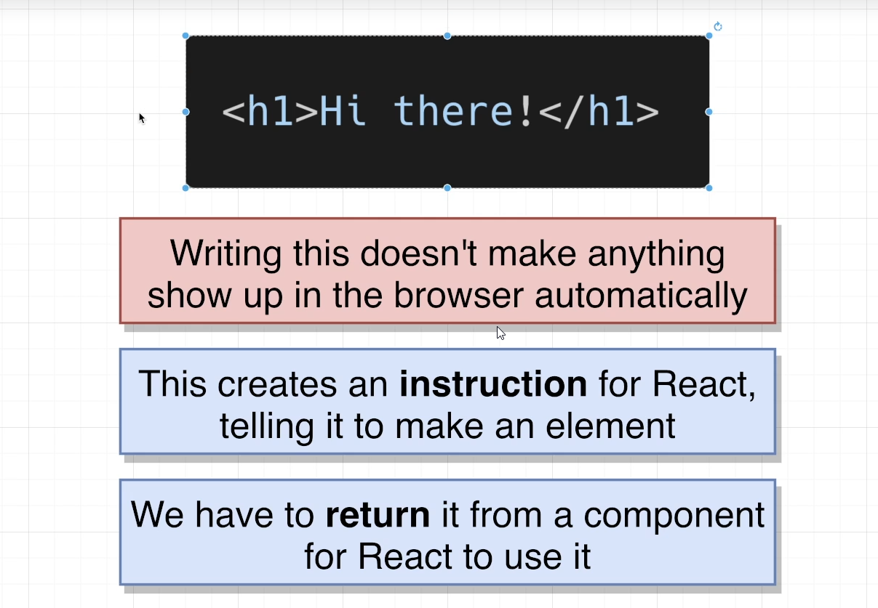

## Printing JavaScript Variables in JSX

1. function App() {
2. let message = 'Bye there';
3. if(Math.random() > 0.5) {
4. message = 'Hello there!';
5. }
6. return <h1>{message}</h1>;
7. }

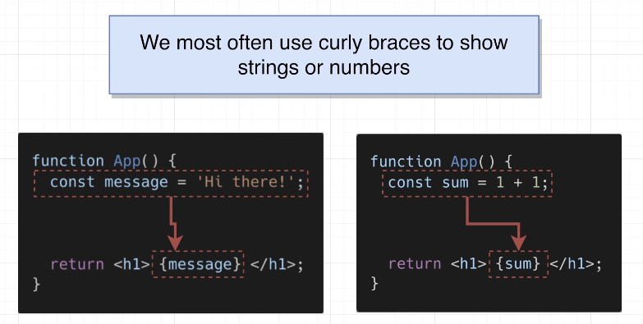 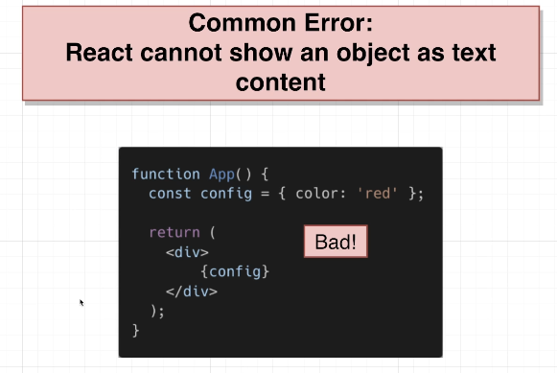

## Shorthand JS Expressions

1. function App() {
2. const date = new Date();
3. const time = date.toLocaleTimeString();
4. return <h1>{time}</h1>;
5. }

function App() {

  return <h1>{new Date().toLocaleTimeString()}</h1>;

}

## Quiz 2: Showing Javascript Values in JSX

## 14. Exercise Overview

## Coding Exercise 1: Quick Practice with JSX

import React from 'react';

function App() {

const name = 'Mehmet';

return (

<div>

My name is:

<h1>{name}</h1>

</div>

);

}

export default App;

## 15. Exercise Solution

## 16. Typical Component Layouts

function App() {

  const name = 'Samantha';

  const age = 23;

  return (

    <h1>

      Hi, my name is {name} and my age is {age}

    </h1>

  );

}

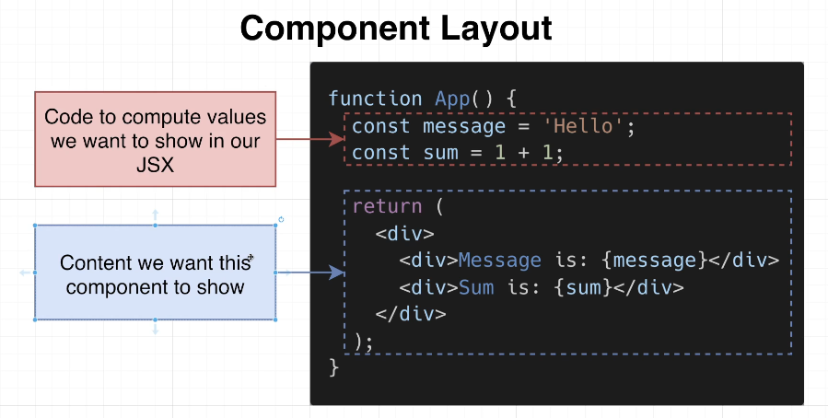

## 17. Customizing Elements with Props

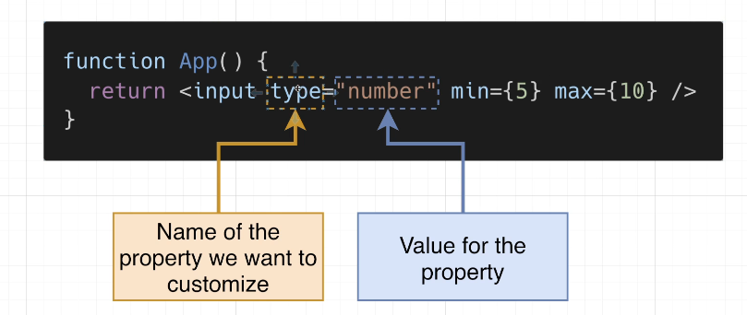

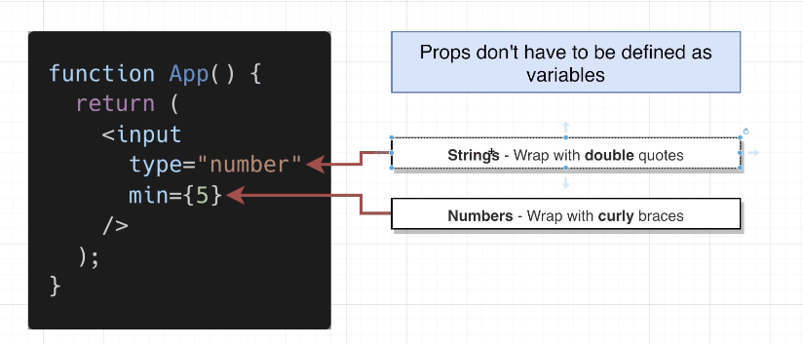

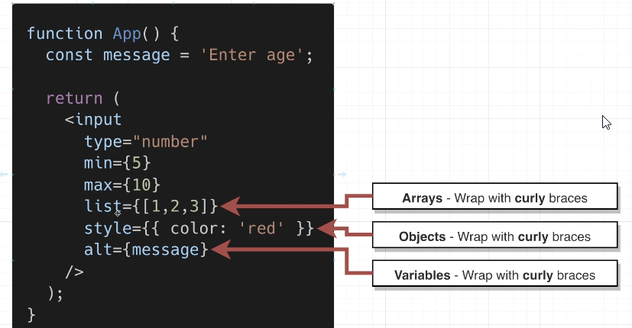

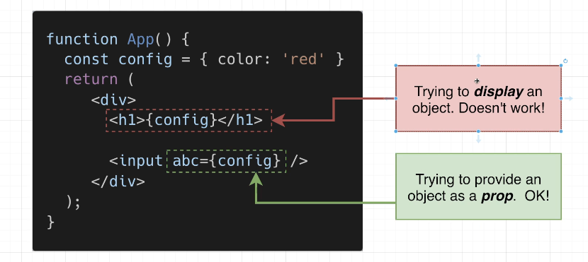

function App() {

  return <input style={{ border: '3px solid red' }} type="number" min={5} />;

}

## 18. Converting HTML to JSX

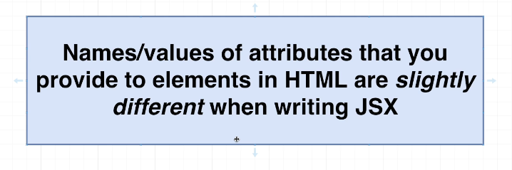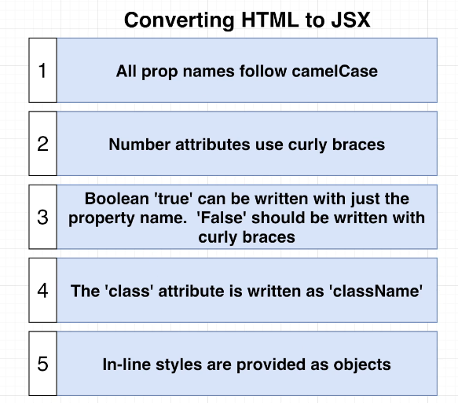

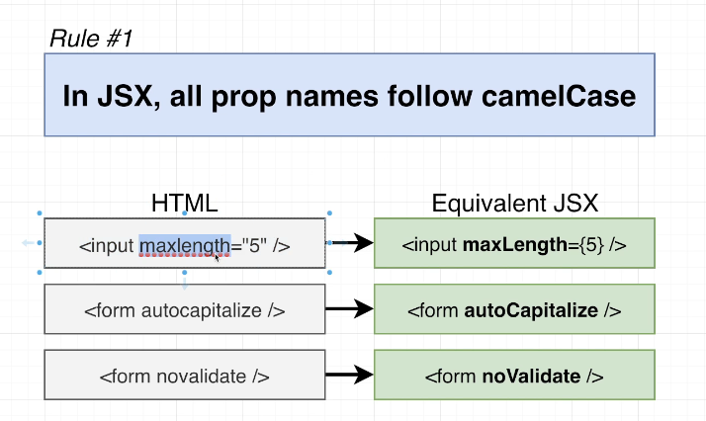

function App() {

  return <textarea autoFocus={true} />;

}

## 19. Applying Styling in JSX

function App() {

  return <input maxLength={5}  />;

}

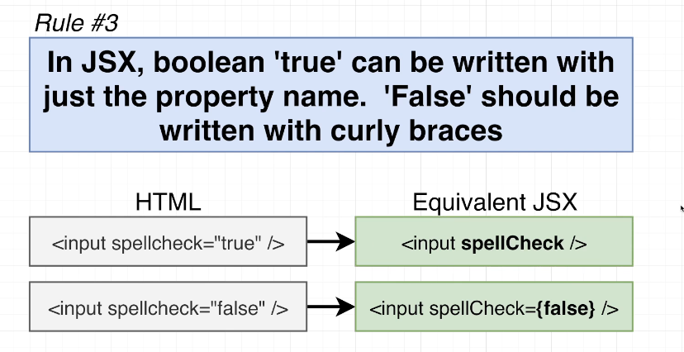

function App() {

  return <input spellCheck={false} />;

}

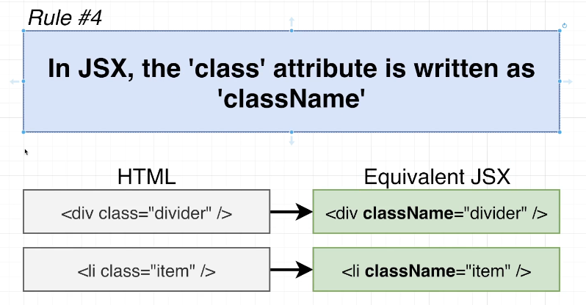

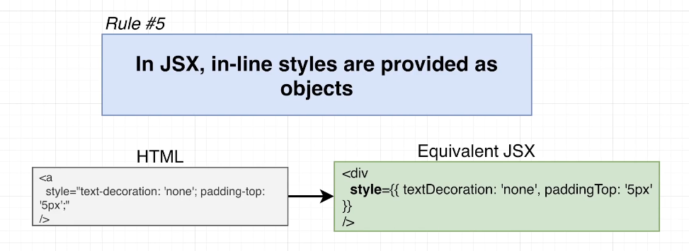

function App() {

  return (

    <div

      style={{

        textDecoration: "none",

        paddingTop: "10px",

        border: "1px solid black",

      }}

    >

      <p>

        test 1 2 3 4 5 6 7 8 9 10 11 12 13 14 15 16 17 18 19 20 21 22 23 24 25

        26 27 28 29 30 31 32 33 34 35 36 37 38 39 40 41 4

      </p>

    </div>

  );

}

## Quiz 3: More on JSX

## Coding Exercise 2: Practice JSX Conversion

## 20. Exercise Solution

function App() {

  return (

    <div className="wrapper">

      <textarea

        readOnly={true}

        maxLength ={3}

        spellCheck ={true}

        style={{ backgroundColor: 'gray'}}

      />

    </div>

  );

}

## 21. Extracting Components

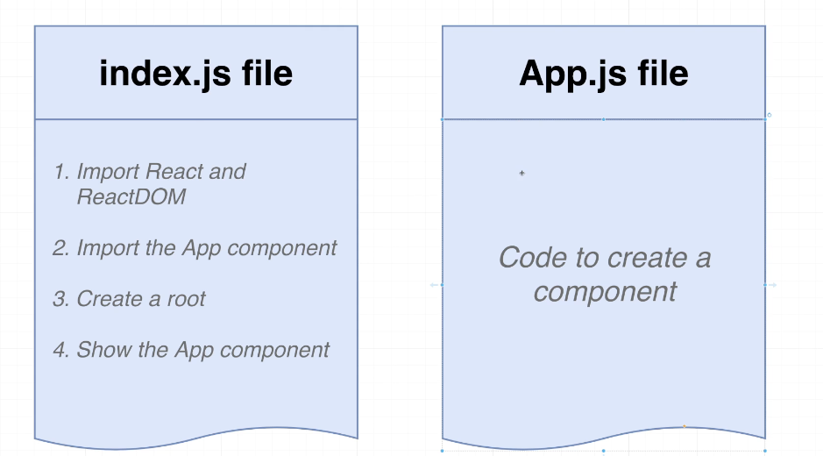 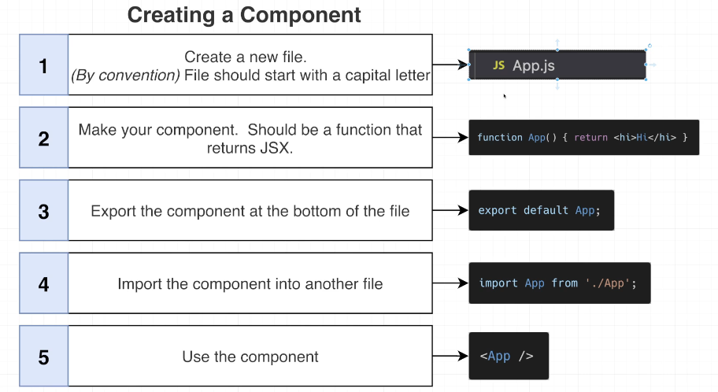

function App() {

  const name = 'Samantha';

  const age = 23;

  return (

    <h1>

      Hi, my name is {name} and my age is {age}

    </h1>

  );

}

## 22. Module Systems Overview

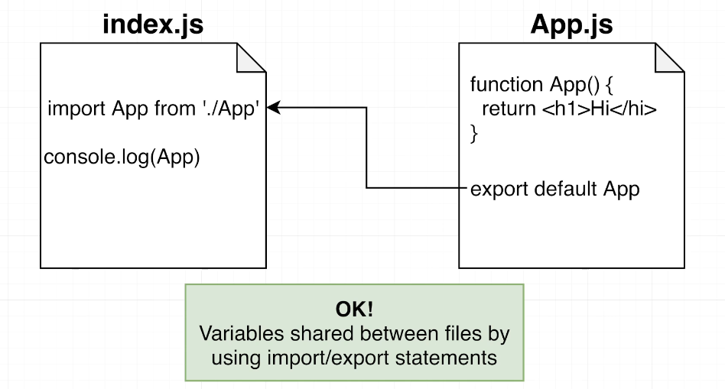

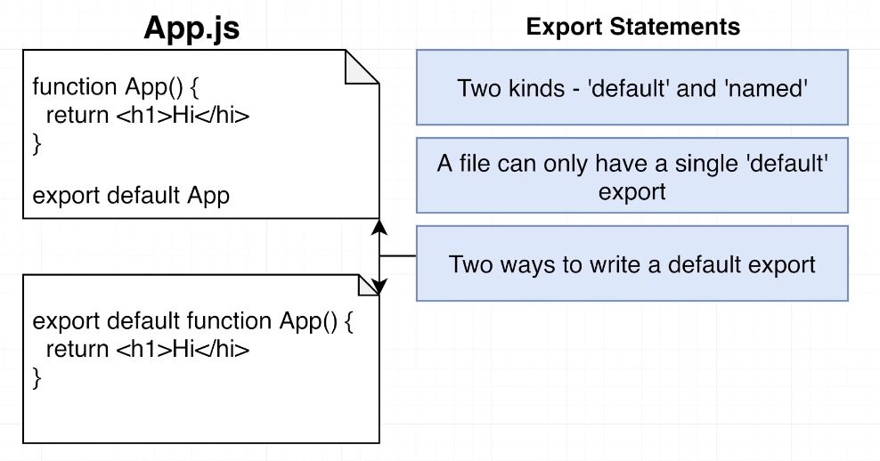 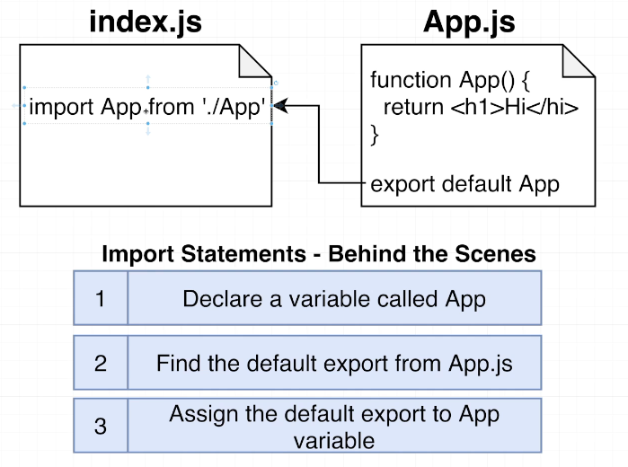

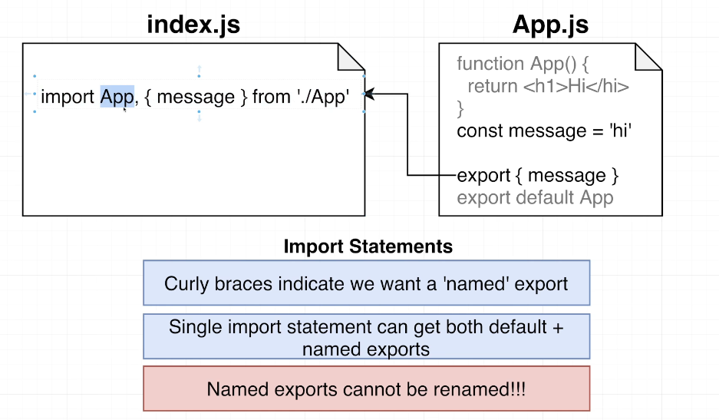

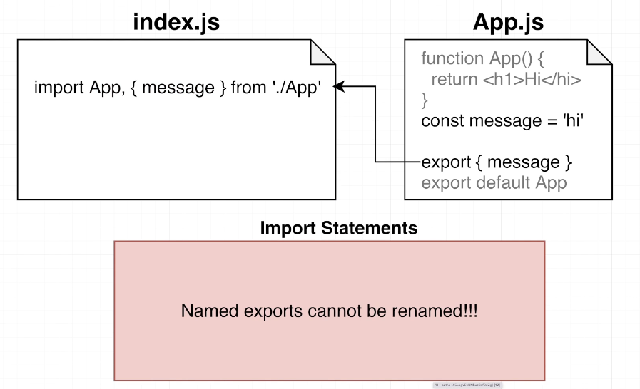

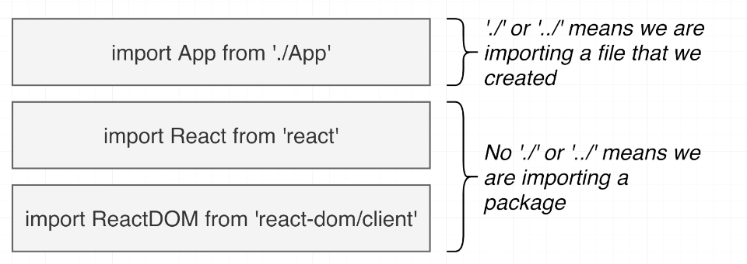

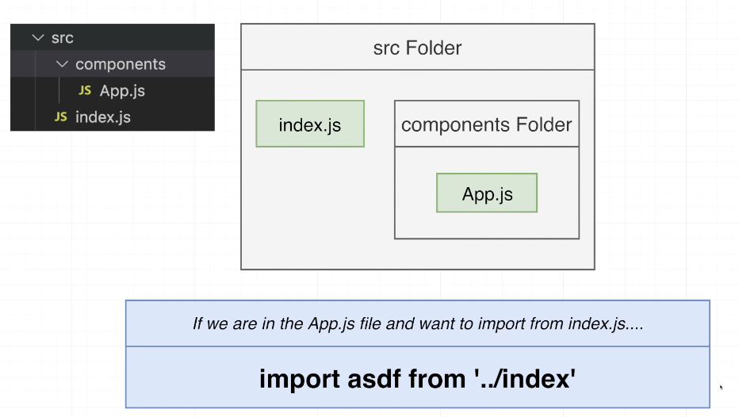

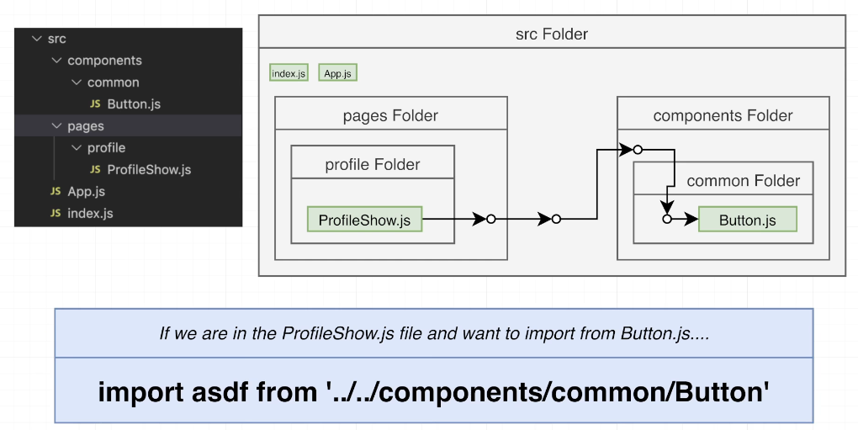

## Quiz 4: Imports and Exports

## 23. Cheatsheet for JSX

<https://jsx-notes.vercel.app/>

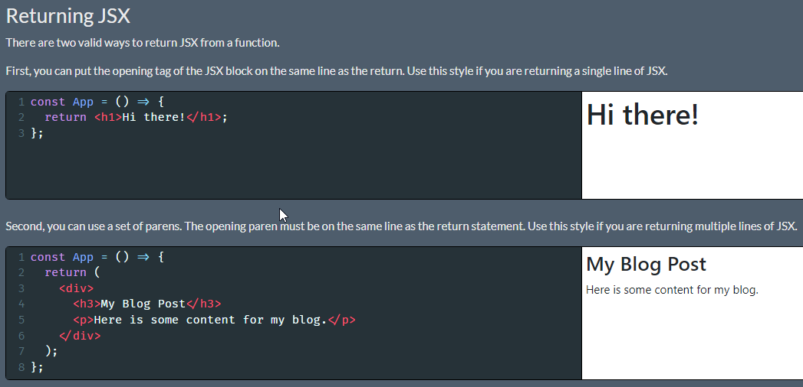

Make sure you always put the opening JSX element or paren on the same line as the return statement. If you don't, Javascript will assume you want to return nothing at all!

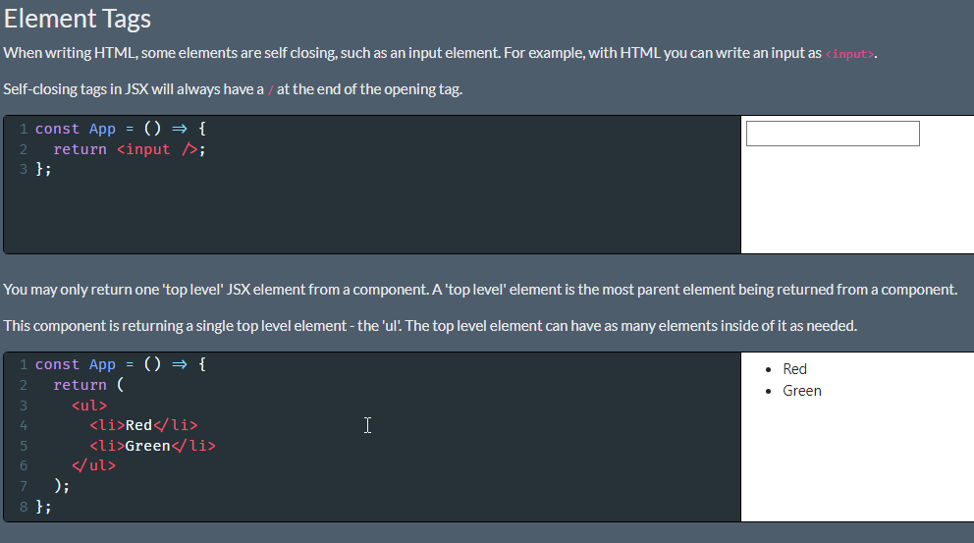

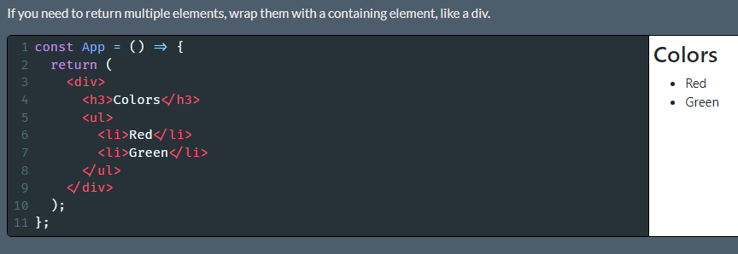

Sometimes, you don't want to insert an extra wrapping element, since it can conflict with some CSS styles. If you don't want to add an extra element, you can return wrap the content in a 'fragment', which looks like an empty JSX element.

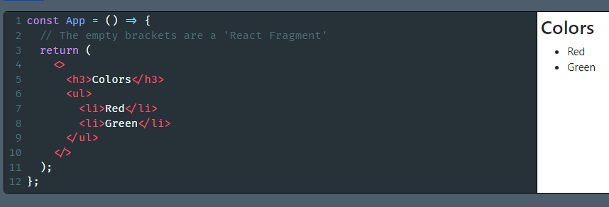

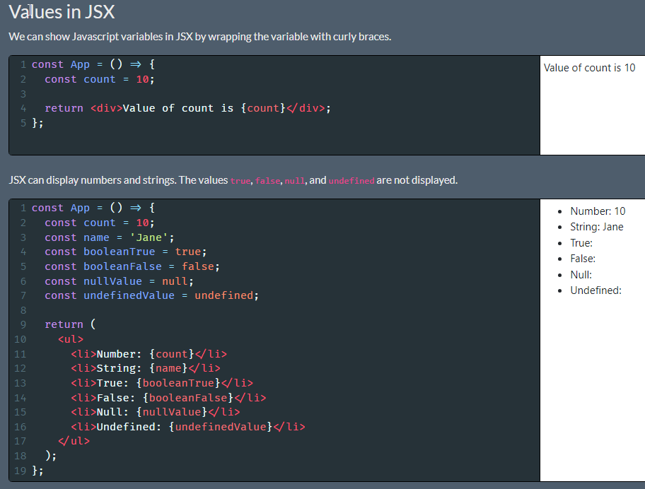

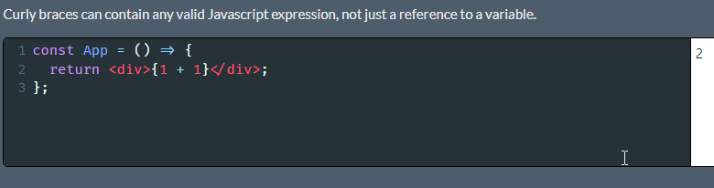

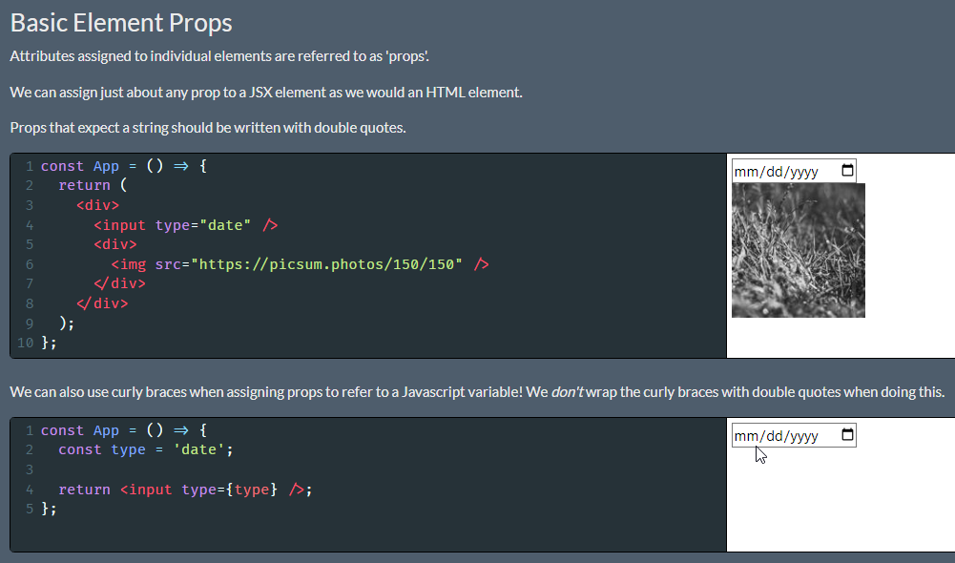

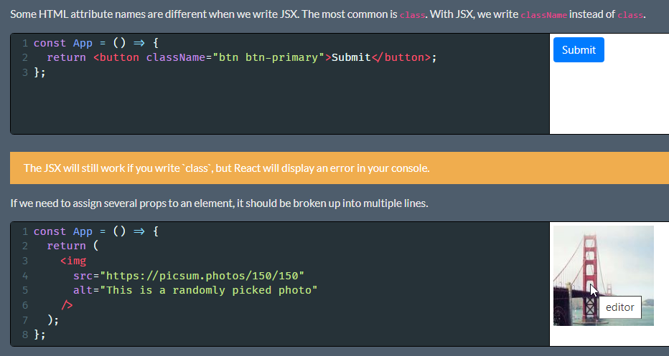

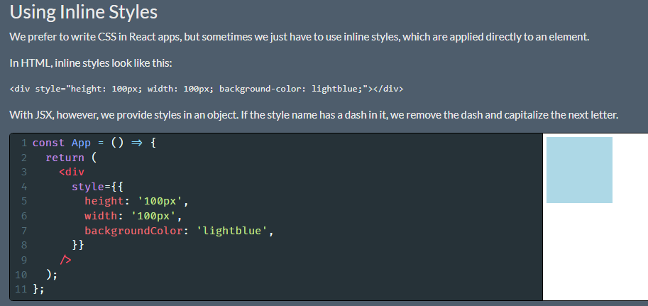

Notice the two sets of curly braces. The outer set means that we are about to write some Javascript in JSX. The inner set creates the object.

Earlier, we saw that objects can't be displayed in JSX. The key word there is 'displayed'. We can't show an object on the screen, but we can provide an object as a prop to an element.

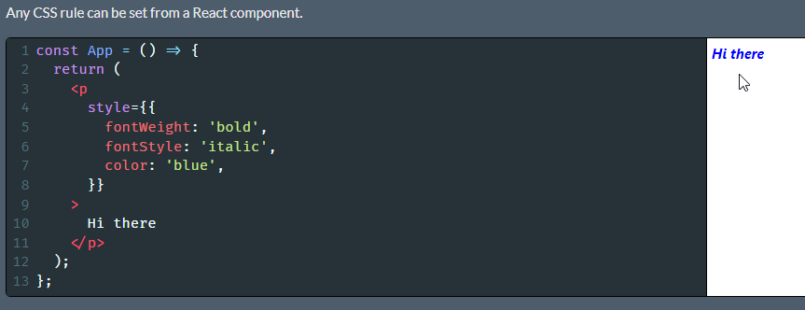

# Section 3: Building with Reusable Components

## 24. Project Overview

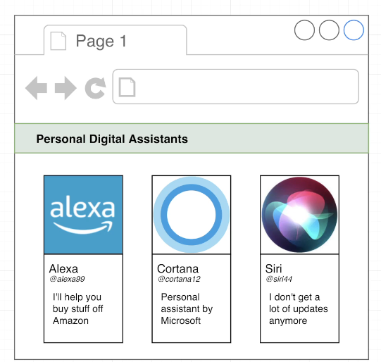

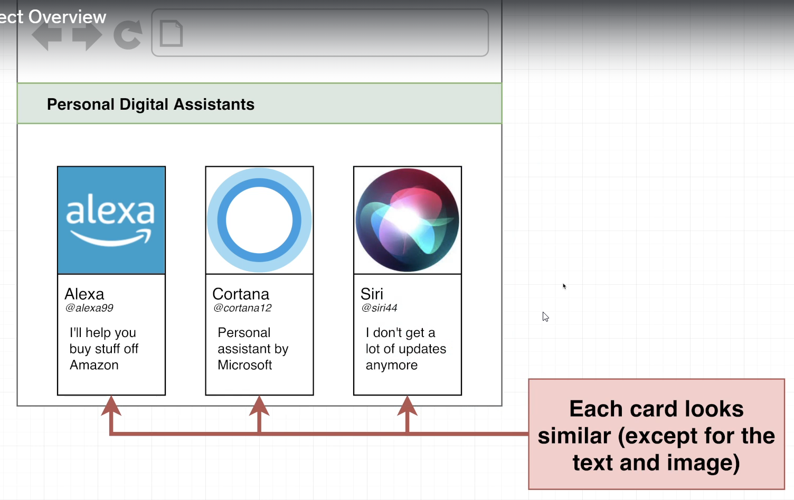

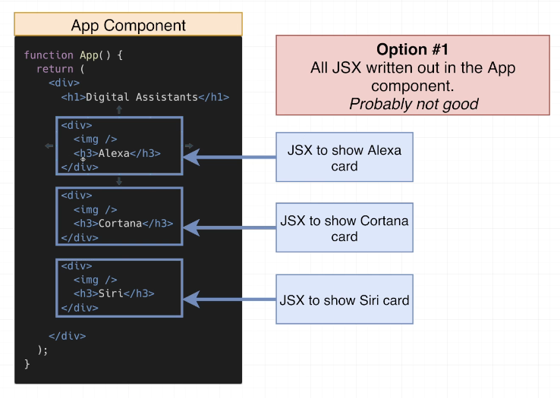

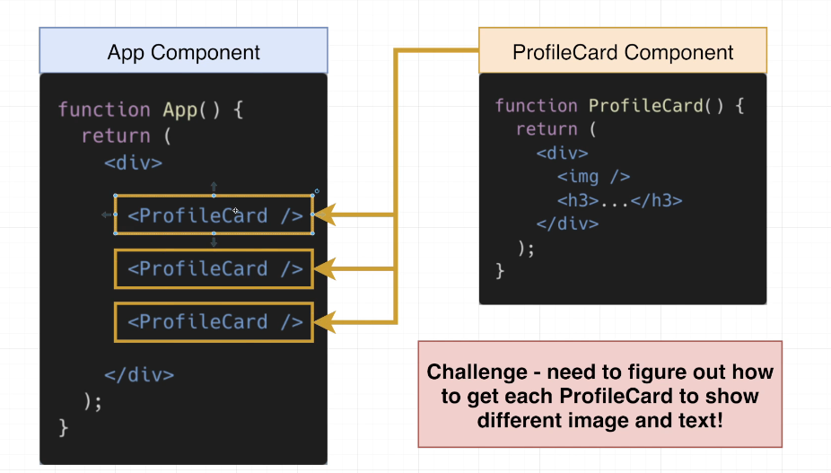

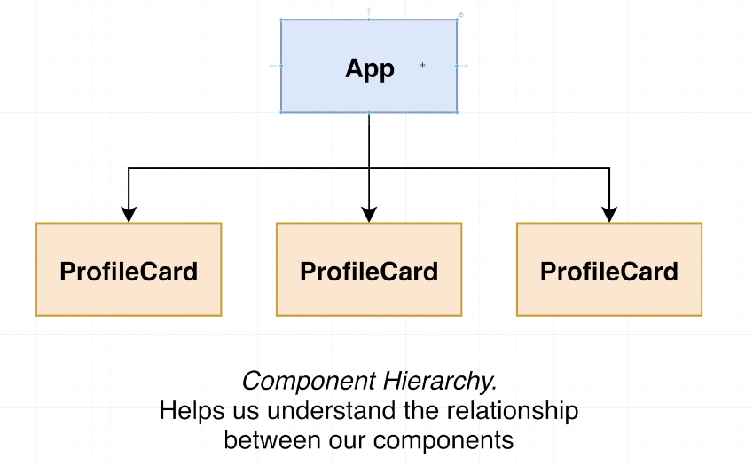

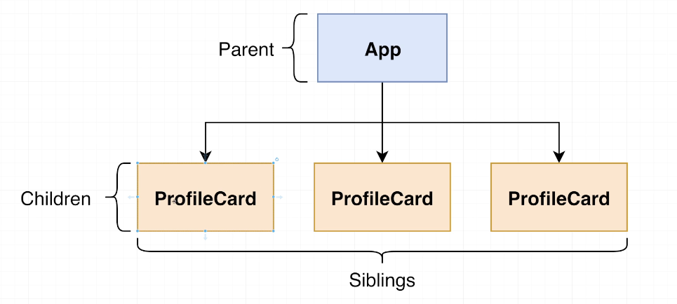

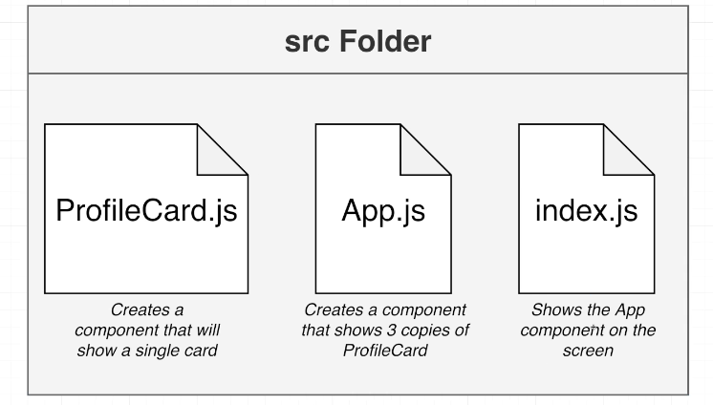

npx create-react-app pdas

cd pdas

npm start

## 25. Creating Core Components

ProfileCard.js

function ProfileCard(){

    return <div>Profile Card</div>

}

export default ProfileCard;

App.js

import ProfileCard from "./ProfileCard";

function App() {

  return (

    <div>

      <div>Personal Digital Assistans</div>

      <ProfileCard />

      <ProfileCard />

      <ProfileCard />

    </div>

  )

}

export default App;

index.js

import React from 'react';

import ReactDOM from 'react-dom/client';

import App from './App';

const el = document.getElementById('root');

const root = ReactDOM.createRoot(el);

root.render(<App />);

## 26. Introducing the Props System

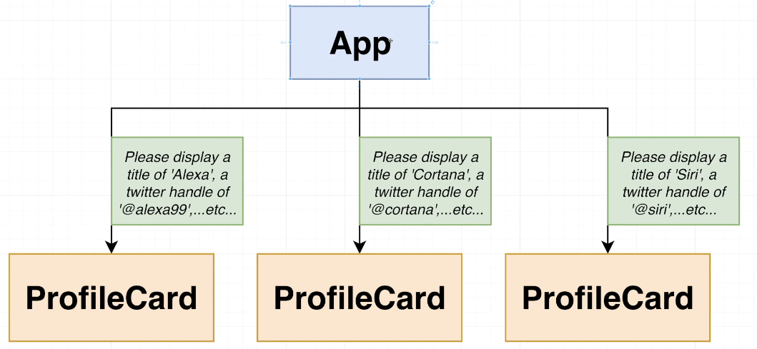

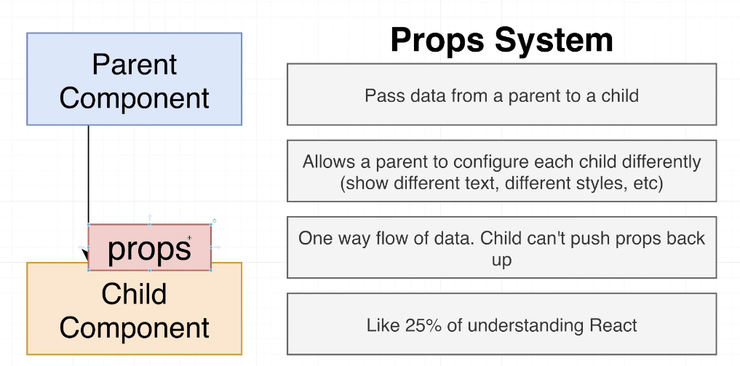

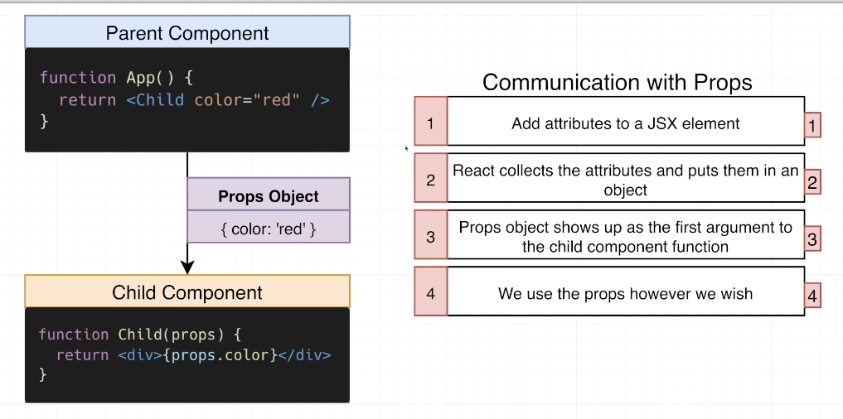

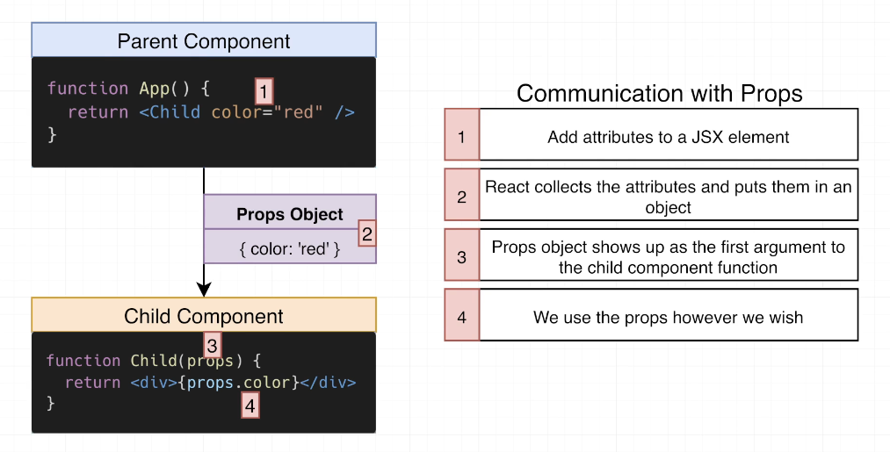

## 27. Picturing the Movement of Data

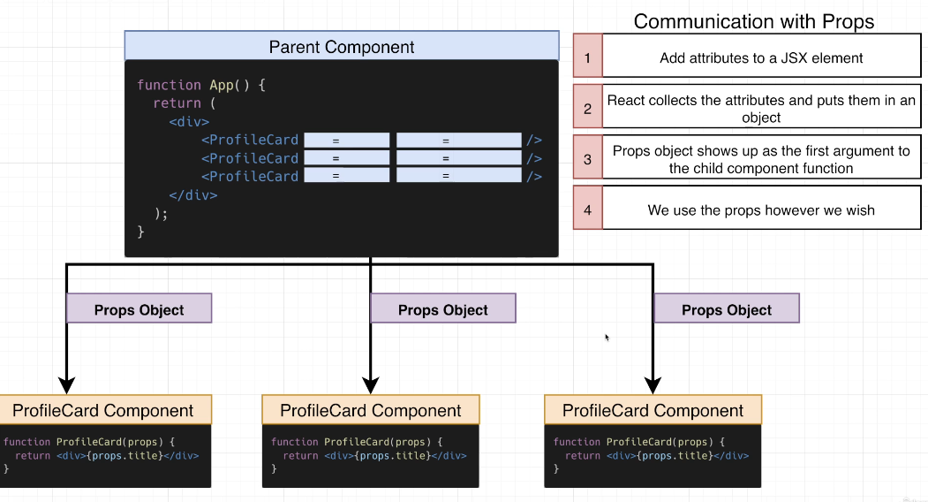

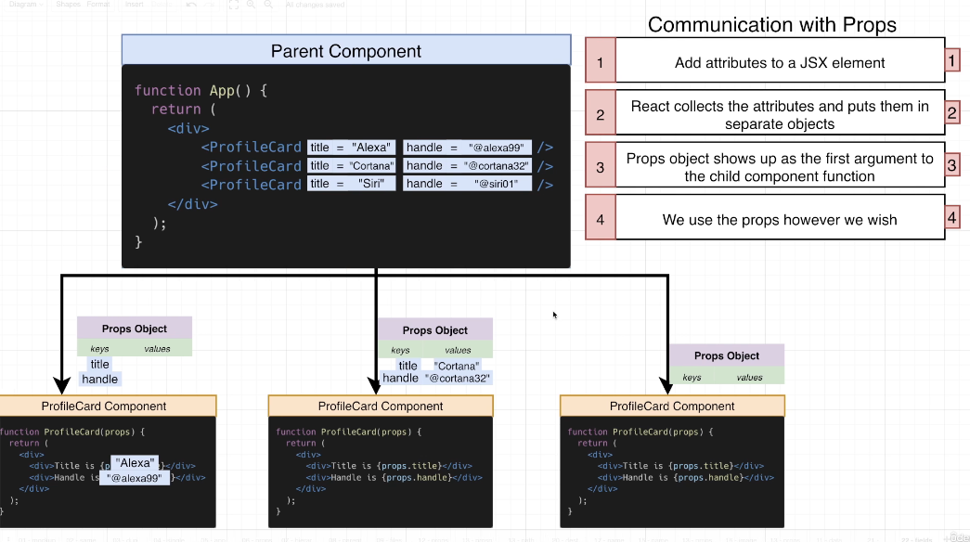

## 28. Adding Props

Index.js

import React from 'react';

import ReactDOM from 'react-dom/client';

import App from './App';

const el = document.getElementById('root');

const root = ReactDOM.createRoot(el);

root.render(<App />);

App.js

import ProfileCard from "./ProfileCard";

function App() {

  return (

    <div>

      <div>Personal Digital Assistans</div>

      <ProfileCard title="Alexa" handle="@alexa99" />

      <ProfileCard title="Cortana" handle="@cortana32" />

      <ProfileCard title="Siri" handle="@siri01" />

    </div>

  )

}

export default App;

ProfileCard.js

function ProfileCard(props){

    console.log('props', props);

    return (

    <div>

        <div>Title is {props.title}</div>

        <div>Handle is {props.handle}</div>

    </div>

    )

}

export default ProfileCard;

## 29. Using Argument Destructuring

function ProfileCard({title , handle}) {

return (

    <div>

        <div>Title is {title}</div>

        <div>Handle is {handle}</div>

    </div>

    )

}

export default ProfileCard;

## Coding Exercise 3: Practice with Props

BrightText.js

import React from 'react';

// This is all done!  No changes needed!

export default function BrightText({ color }) {

  const style = { color: color };

  // You might see an error on this line from the code editor

  // There is no error, no changes are needed

  return <h1 style={style}>Hi!</h1>

}

App.js

import React from 'react';

import BrightText from './BrightText'

function App() {

    return (

        <div>

          <BrightText color = "red" />

          <BrightText color = "green" />

          <BrightText color = "blue" />

        </div>

    );

}

export default App;

## 31. The React Developer Tools

Install react-developer-tools from the <https://react.dev/learn/react-developer-tools> to your default internet browser for debugging react app.

## 32. The Most Common Props Mistake

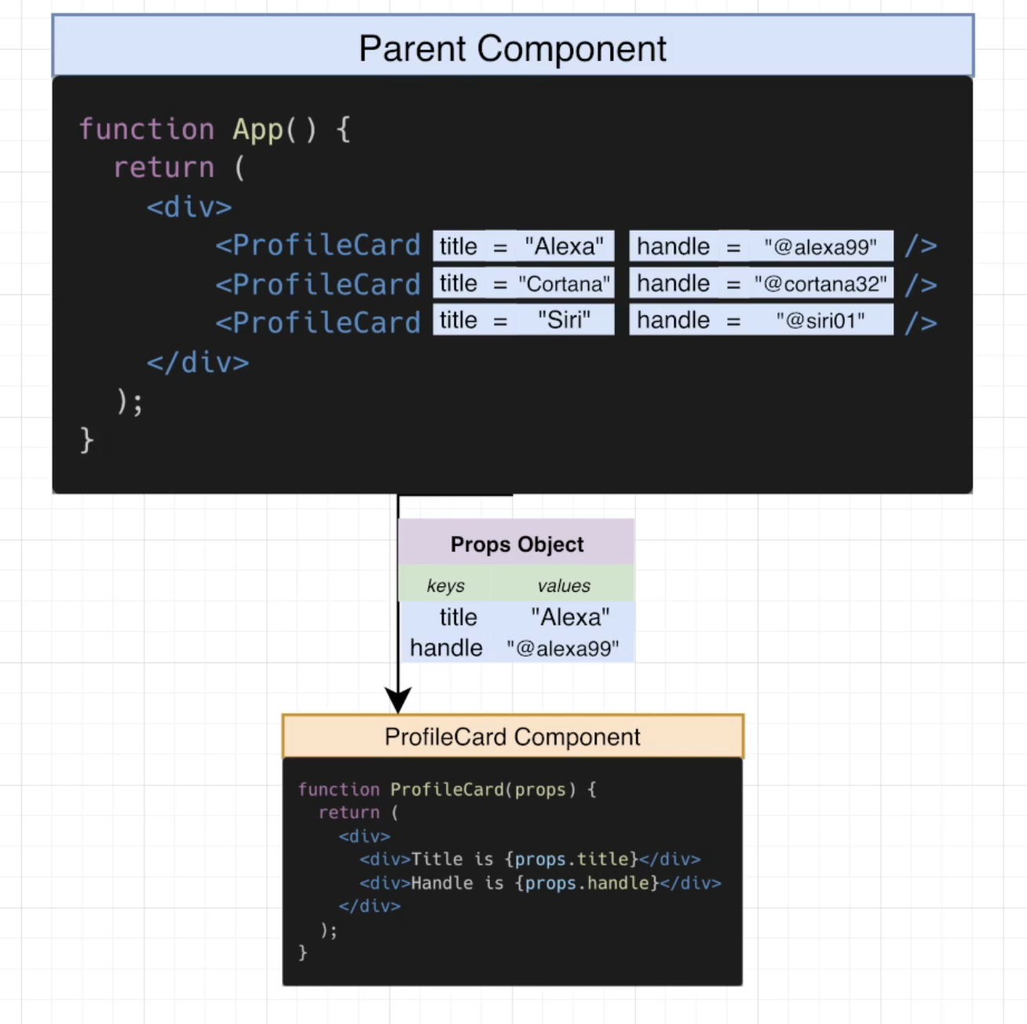

## Quiz 5: Communicating With Props

## 33. Images for the App

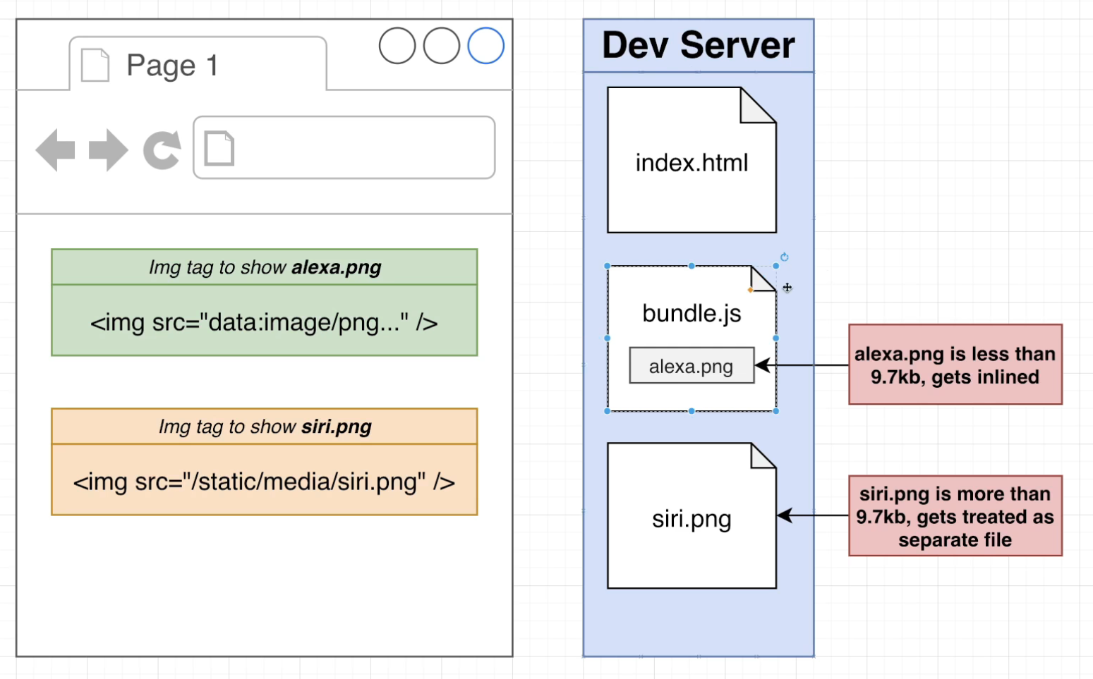

## 34. Including Images

import ProfileCard from "./ProfileCard";

import AlexaImage from './images/alexa.png';

import CortanaImage from './images/cortana.png';

import SiriImage from './images/siri.png';

console.log(AlexaImage)

console.log(CortanaImage)

console.log(SiriImage)

function App() {

  return (

    <div>

      <div>Personal Digital Assistans</div>

      <ProfileCard title="Alexa" handle="@alexa99" image={AlexaImage} />

      <ProfileCard title="Cortana" handle="@cortana32" image={CortanaImage} />

      <ProfileCard title="Siri" handle="@siri01" image={SiriImage} />

    </div>

  )

}

export default App;

## 35. Handling Image Accessibility

function ProfileCard({title , handle, image}) {

return (

    <div>

        <img src={image} alt="pda logo" />

        <div>Title is {title}</div>

        <div>Handle is {handle}</div>4

    </div>

    )

}

export default ProfileCard;

## 36. Review on how CSS Works

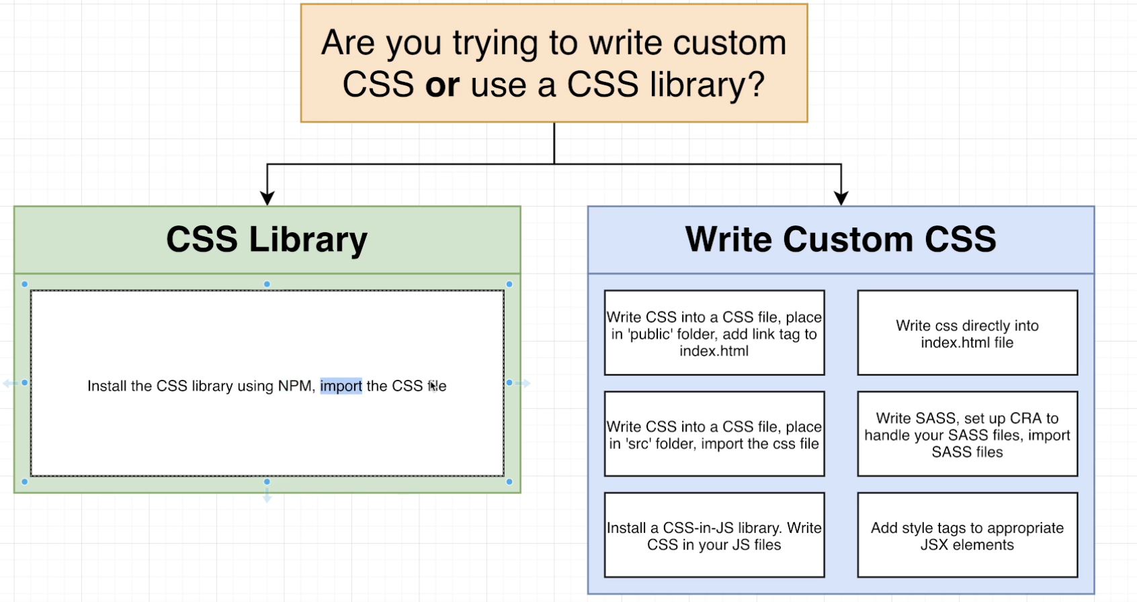

## 37. Adding CSS Libraries with NPM

<https://bulma.io/documentation/>

npm install bulma

## 38. A Big Pile of HTML!

Index.js

import React from 'react';

import ReactDOM from 'react-dom/client';

import App from './App';

const el = document.getElementById('root');

const root = ReactDOM.createRoot(el);

root.render(<App />);

App.js

import "bulma/css/bulma.css";

import ProfileCard from "./ProfileCard";

import AlexaImage from "./images/alexa.png";

import CortanaImage from "./images/cortana.png";

import SiriImage from "./images/siri.png";

// console.log(AlexaImage)

// console.log(CortanaImage)

// console.log(SiriImage)

function App() {

  return (

    <div>

      <div>Personal Digital Assistans</div>

      <div className="container">

        <section className="section">

          <div className="column is-4">

            <ProfileCard title="Alexa" handle="@alexa99" image={AlexaImage} />

          </div>

          <div className="column is-4">

            <ProfileCard

              title="Cortana"

              handle="@cortana32"

              image={CortanaImage}

            />

          </div>

          <div className="column is-4">

            <ProfileCard title="Siri" handle="@siri01" image={SiriImage} />

          </div>

        </section>

      </div>

    </div>

  );

}

export default App;

ProfileCard.js

function ProfileCard({ title, handle, image }) {

  return (

    <div className="card">

      <div className="card-image">

        <figure className="image is-1by1">

          <img src={image} alt="pda logo" />

        </figure>

      </div>

      <div className="card-content">

        <div className="media-content">

          <p className="title is-4">{title}</p>

          <p className="subtitle is-6">{handle}</p>

        </div>

      </div>

    </div>

  );

}

export default ProfileCard;

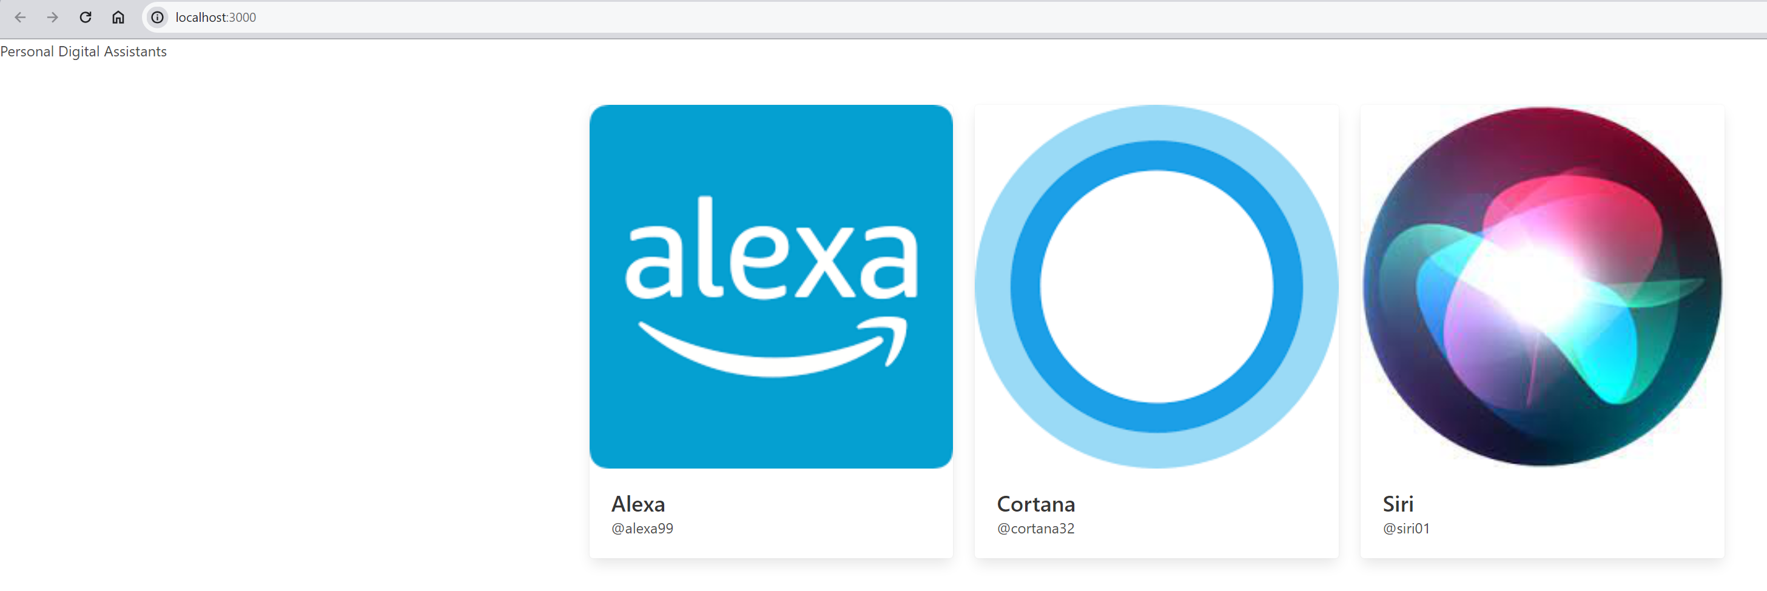

## 39. Last Bit of Styling

Index.js

import React from 'react';

import ReactDOM from 'react-dom/client';

import App from './App';

const el = document.getElementById('root');

const root = ReactDOM.createRoot(el);

root.render(<App />);

App.js

import 'bulma/css/bulma.css';

import ProfileCard from './ProfileCard';

import AlexaImage from './images/alexa.png';

import CortanaImage from './images/cortana.png';

import SiriImage from './images/siri.png';

function App() {

  return (

    <div>

      <section className="hero is-primary">

        <div className="hero-body">

          <p className="title">Personal Digital Assistants</p>

        </div>

      </section>

      <div className="container">

        <section className="section">

          <div className="columns">

            <div className="column is-4">

              <ProfileCard

                title="Alexa"

                handle="@alexa99"

                image={AlexaImage}

                description="Alexa was created by Amazon and helps you buy things."

              />

            </div>

            <div className="column is-4">

              <ProfileCard

                title="Cortana"

                handle="@cortana32"

                image={CortanaImage}

                description="Cortana was made by Microsoft. Who knows what it does?"

              />

            </div>

            <div className="column is-4">

              <ProfileCard

                title="Siri"

                handle="@siri01"

                image={SiriImage}

                description="Siri was made by Apple and is being phased out"

              />

            </div>

          </div>

        </section>

      </div>

    </div>

  );

}

export default App;

ProfileCard.js

function ProfileCard({ title, handle, image, description }) {

  return (

    <div className="card">

      <div className="card-image">

        <figure className="image is-1by1">

          <img src={image} alt="pda logo" />

        </figure>

      </div>

      <div className="card-content">

        <div className="media-content">

          <p className="title is-4">{title}</p>

          <p className="subtitle is-6">{handle}</p>

        </div>

        <div className="content">{description}</div>

      </div>

    </div>

  );

}

export default ProfileCard;

The Output:

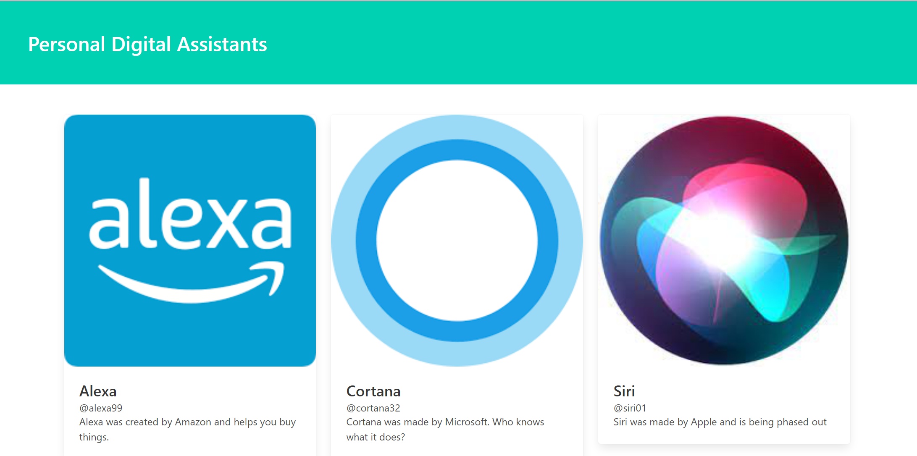

# Section 4: State: How to Change Your App

## 40. App Overview

npx create-react-app animals

## 41. Initial App Setup

npm start

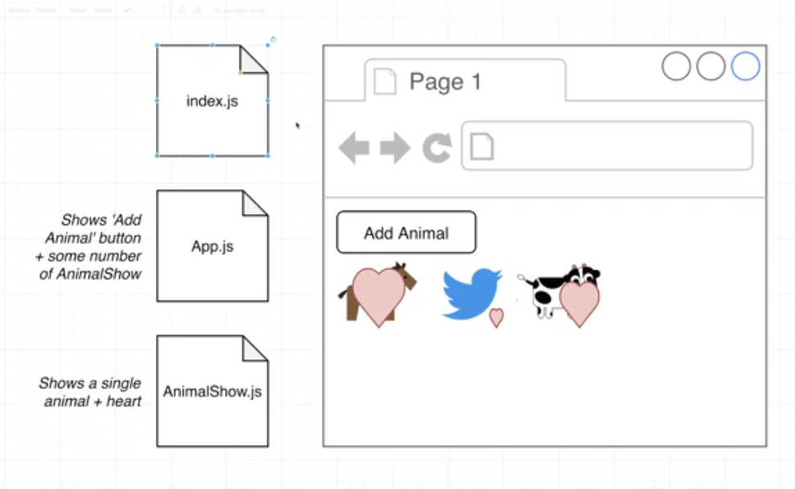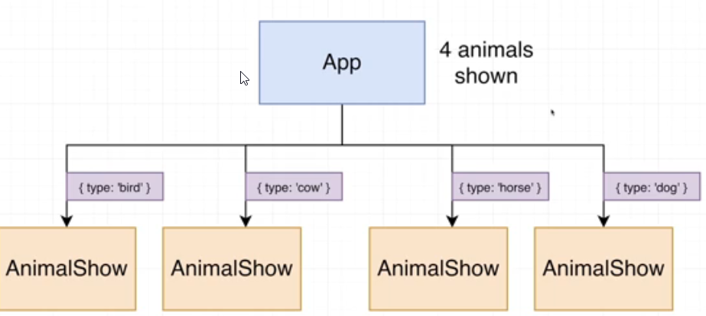

## 42. Introducing the Event System

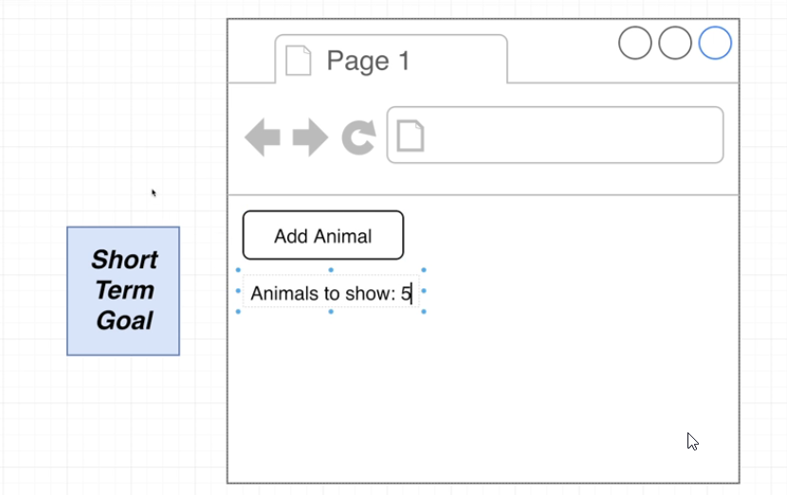

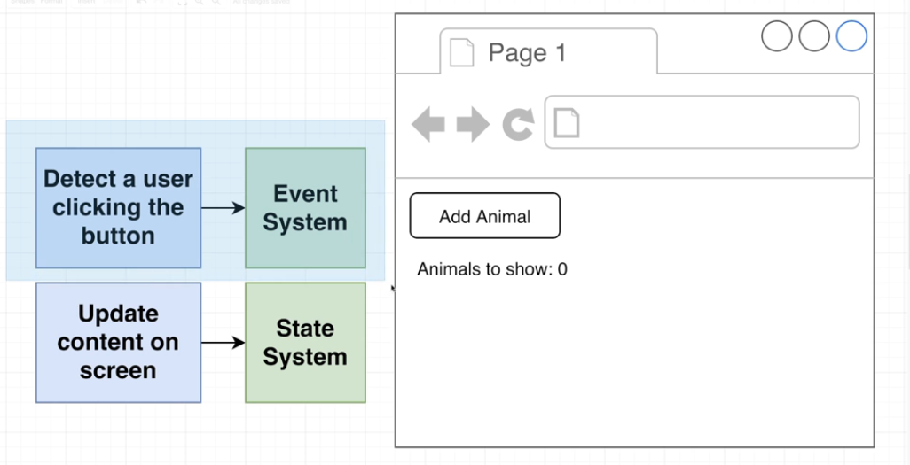

App.js

function App() {

    const handleClick = () => {

        console.log('Button was clicked')

    };

    return (

    <div>

        <button onClick={handleClick}>Add Animal</button>

        </div>

    )

}

export default App;

## 43. Events in Detail

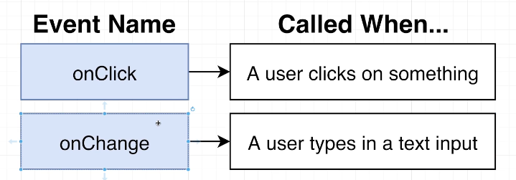

App.js

function App() {

    const handleClick = () => {

        console.log('Button was clicked')

    };

    const handleMouseMove = () => {

        console.log('Mouse moved inside of the button')

    };

    return (

    <div>

        <button onClick={handleClick} onMouseMove={handleMouseMove}>Add Animal</button>

        </div>

    )

}

export default App;

## 44. Variations on Event Handlers

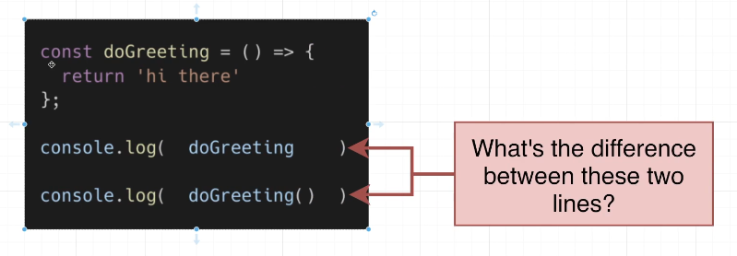

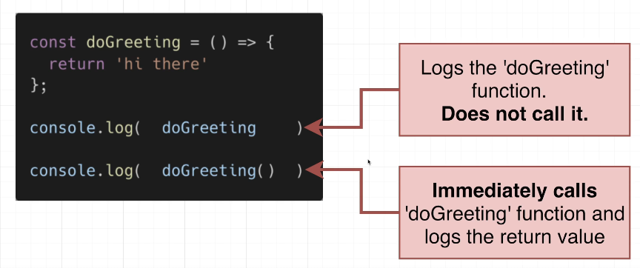

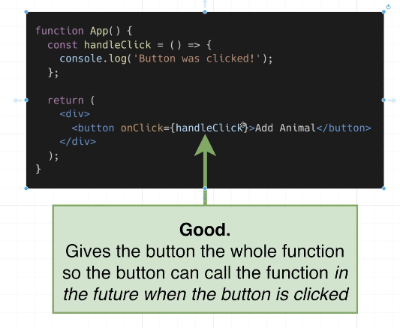

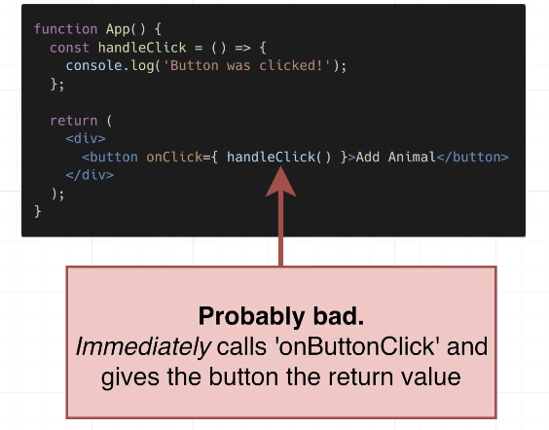

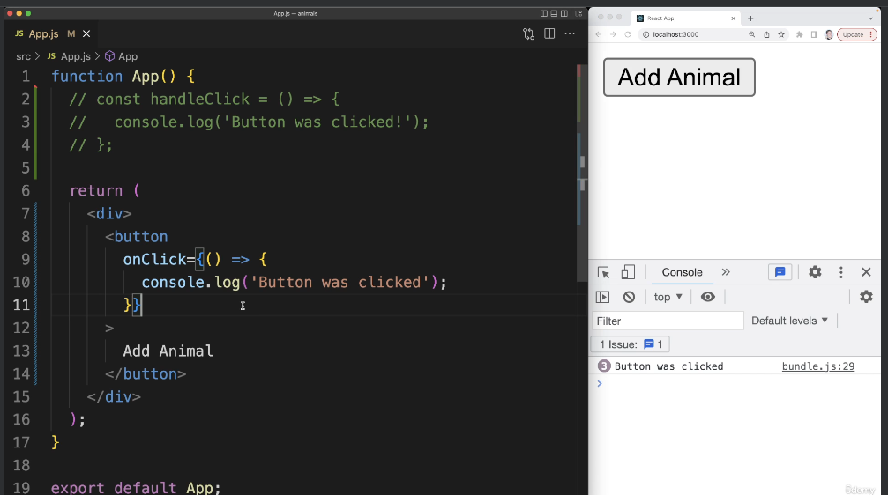

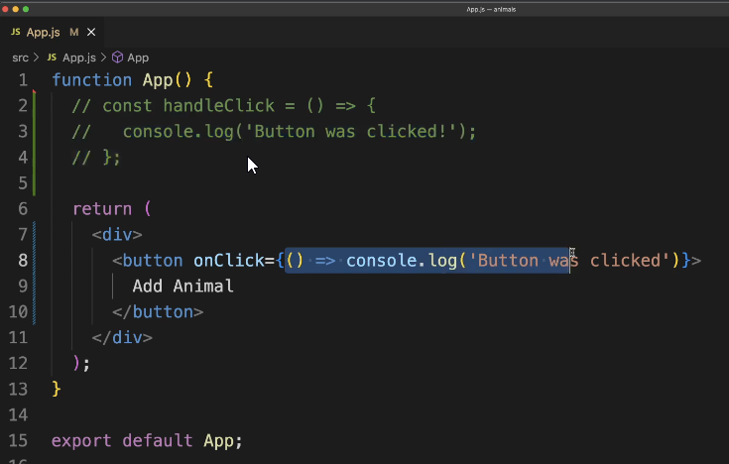

## Coding Exercise 4: Exercise with Events

import React from 'react';

function App() {

    return (

        <div>

            <button onClick={() => console.log('Hello there!')}>Click Me!</button>

        </div>

    );

}

export default App;

## 45. Exercise Solution

## 46. Introducing the State System

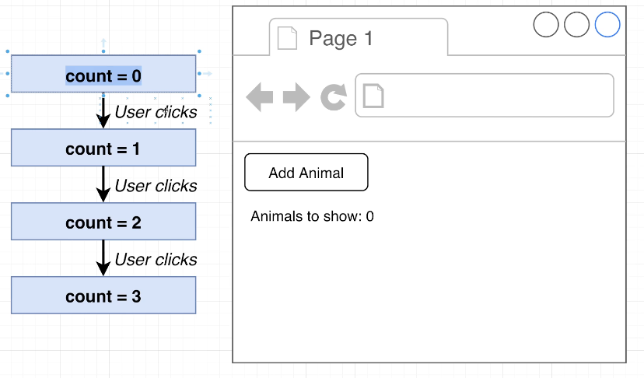

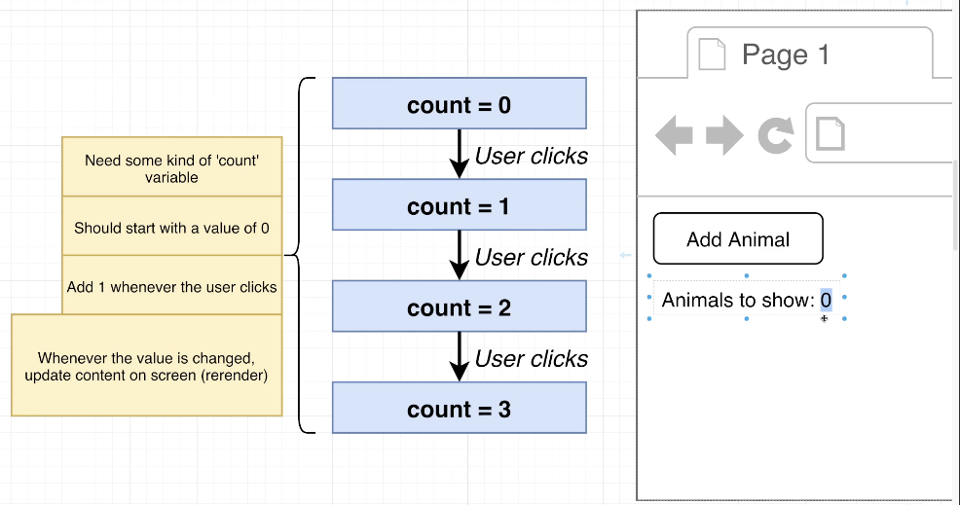

import { useState } from "react";

function App() {

  const [count, setCount] = useState(0);

  const handleClick = () => {

    setCount(count + 1);

  };

  return (

    <div>

      <button onClick={handleClick}>Add Animal</button>

      <div>Number of animals: {count}</div>

    </div>

  );

}

export default App;

## 47. More on State

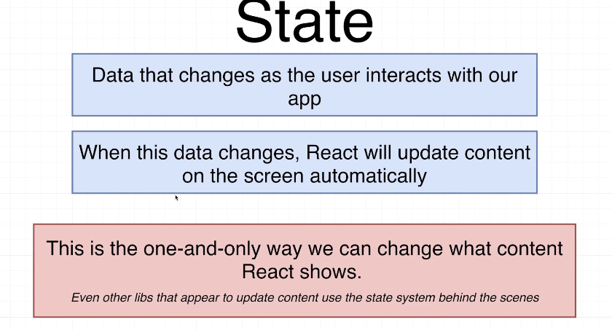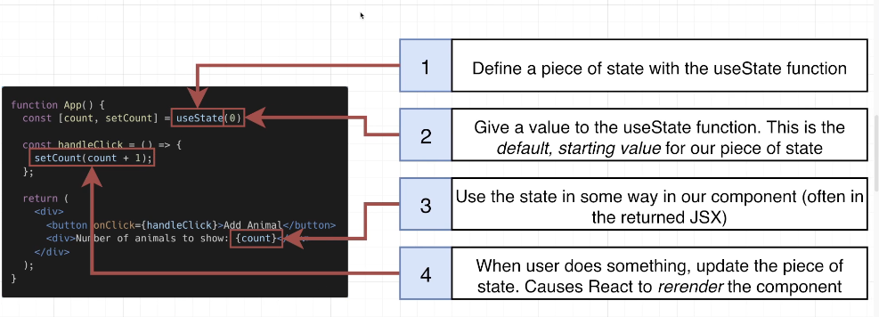

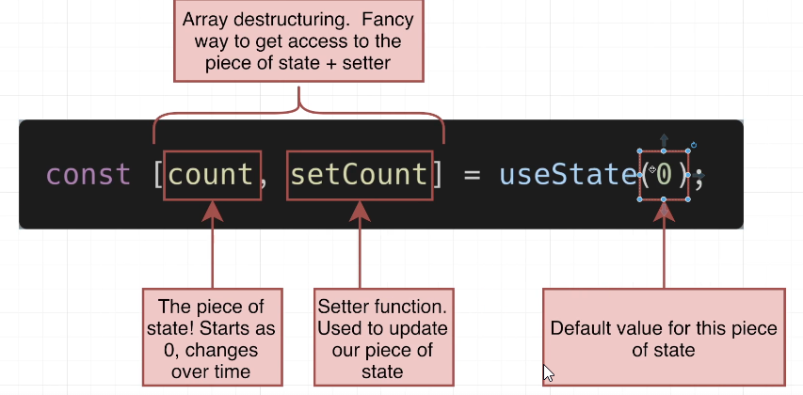

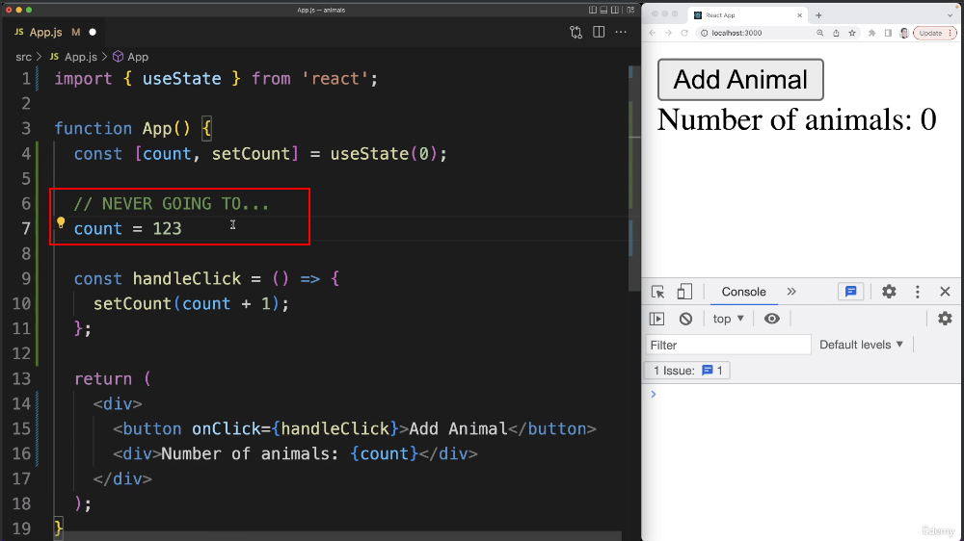

## 48. Understanding the Re-Rendering Process

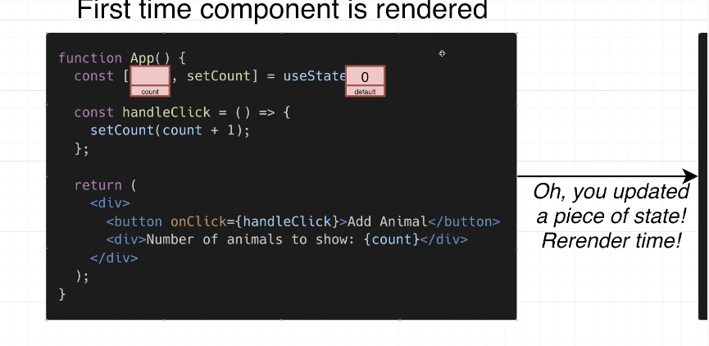

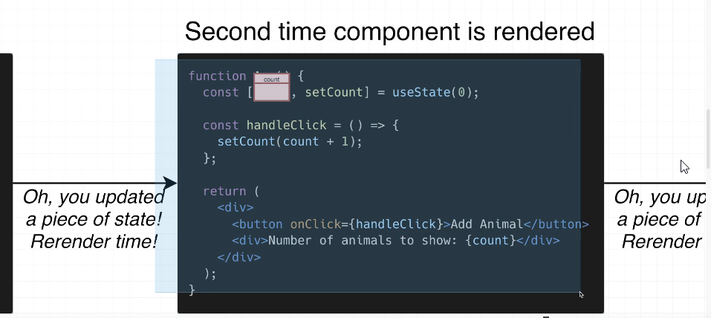

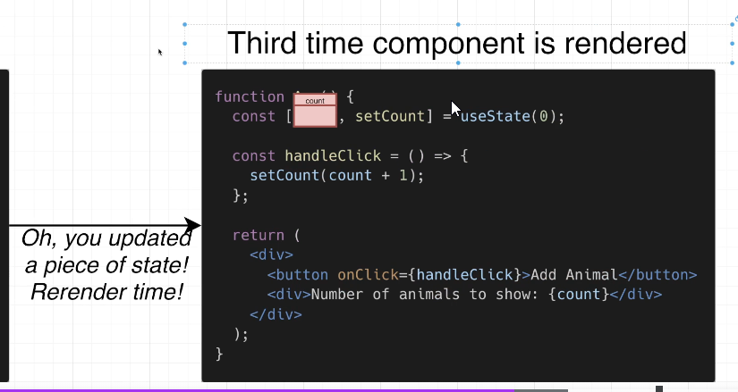

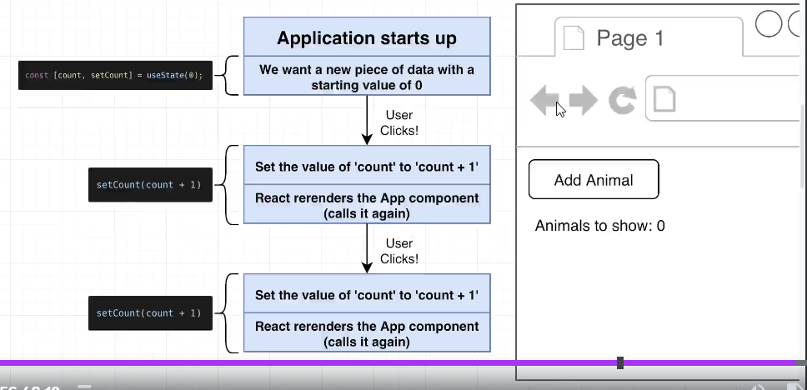

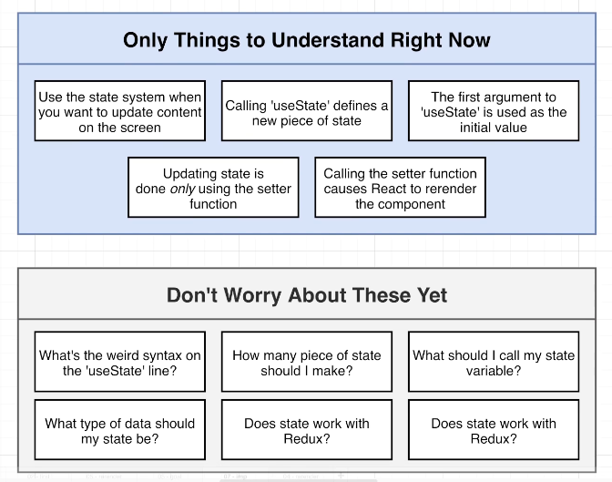

## 49. Why Array Destructuring?

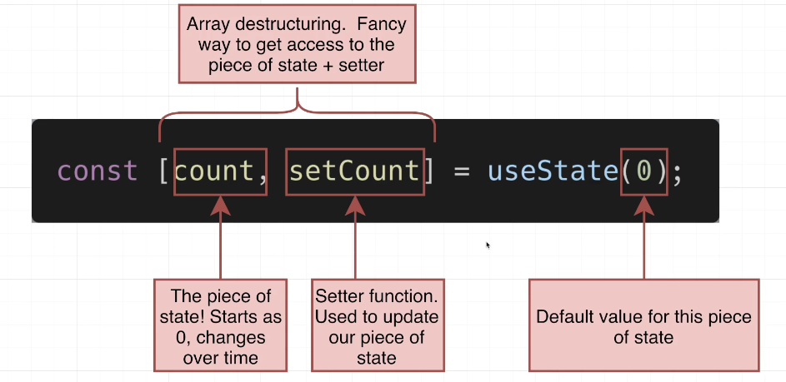

function App() {

  function makeArray(){

    return [1, 10, 32,40];

  }

  const myArray = makeArray();

  const firstElement1 = myArray[0];

  const secondElement1 = myArray[1];

  console.log(firstElement1, secondElement1);

  // Array Desctructing

  const [firstElement2, secondElement2] = makeArray();

  console.log(firstElement2, secondElement2);

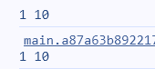

 console.log(useState(50));

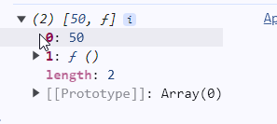

useState implementation is as follows:

function useState(defaultValue) {

  return {

    yourState: defaultValue,

    yourSetter: () => {}

  };

}

Variable declaration and usage of useState function is as follows:

function App() {

  const stageConfig = useState(0);

  const count = stageConfig.yourState;

  const setCount = stageConfig.yourSetter;

object destruction style is same with previous style, but it is style longer

const {yourState: count, yourSetter: setCount} = useState(0);

array destruction style is the shortest way to using state

import { useState } from "react";

function App() {

  const [count, setCount] = useState(0);

## 50. Back to the App

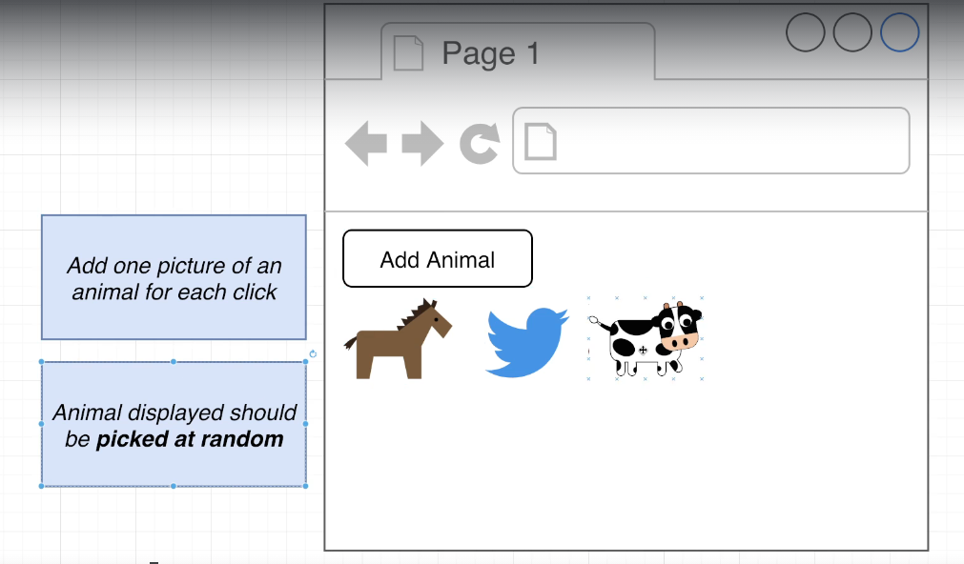

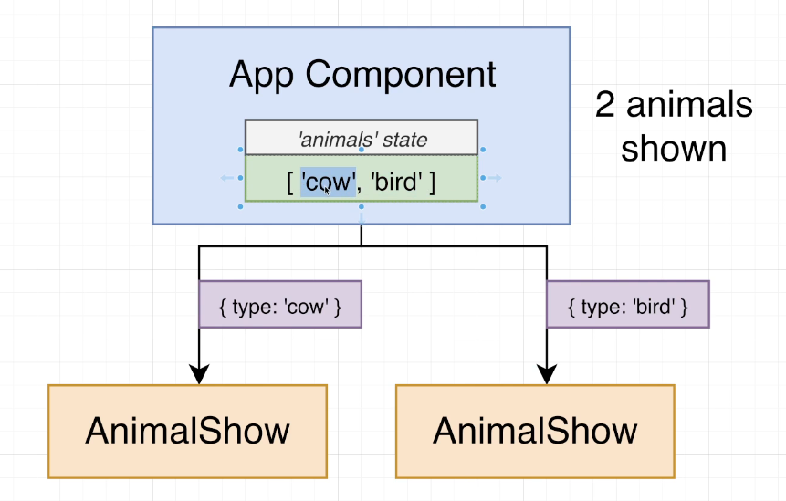

## 51. Picking a Random Element

App.js

function getRandomAnimal() {

  const animals = ["bird", "cat", "cow", "dog", "gator", "horse"];

  return animals[Math.floor(Math.random() * animals.length)];

}

function App() {

  const [animals, setAnimals] = useState([]);

  const handleClick = () => {

     setAnimals([...animals, getRandomAnimal()]);

  };

## 52. List Building in React

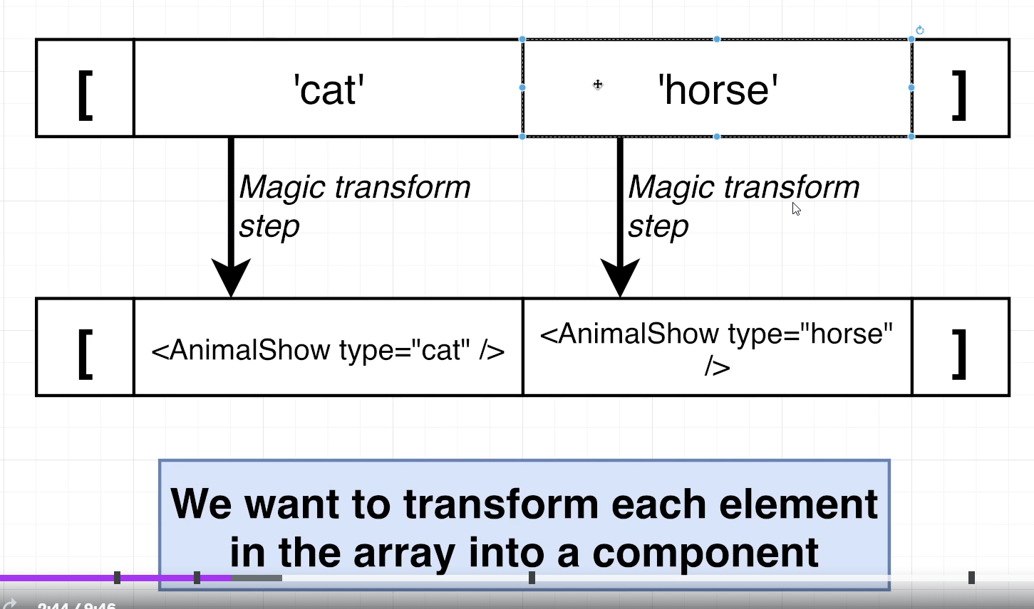

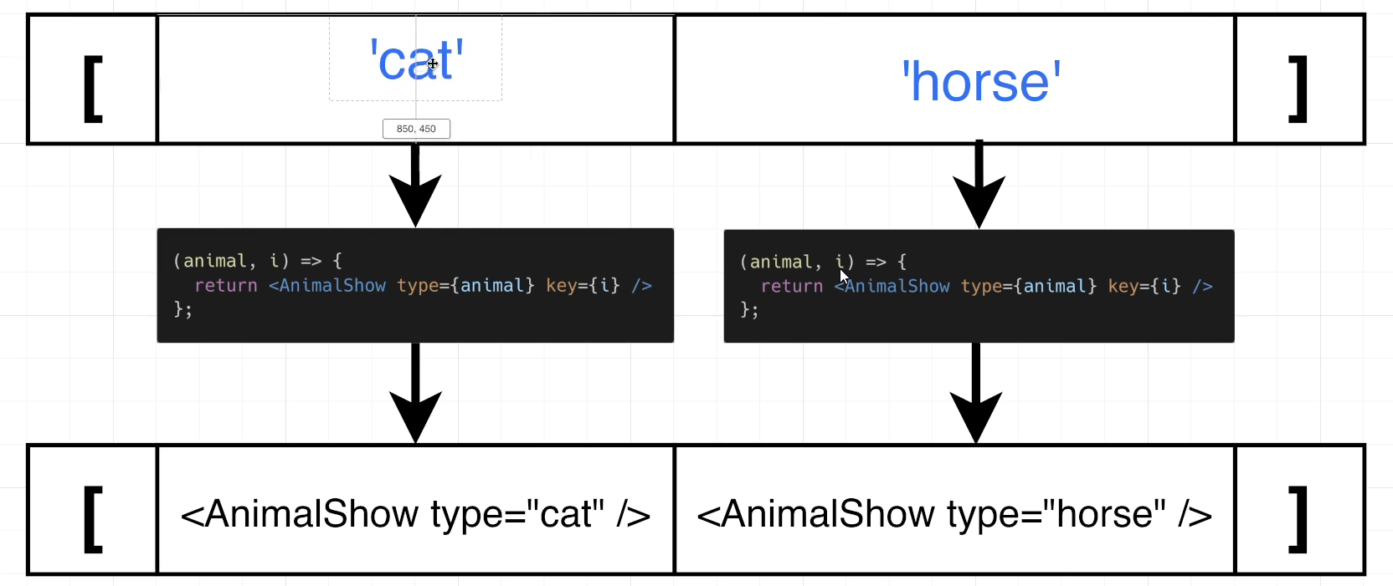

## 53. Images for the App

## 54. Loading and Showing SVGs

AnimalShow.js

import bird from "./svg/bird.svg";

import cat from "./svg/cat.svg";

import cow from "./svg/cow.svg";

import dog from "./svg/dog.svg";

import gator from "./svg/gator.svg";

import heart from "./svg/heart.svg";

import horse from "./svg/horse.svg";

const svgMap = {

  bird,

  cat,

  cow,

  dog,

  gator,

  horse,

};

function AnimalShow({ type }) {

  return (

    <div>

      <img alt="animal" src={svgMap[type]} />

    </div>

  );

}

export default AnimalShow;

## 55. Increasing Image Size

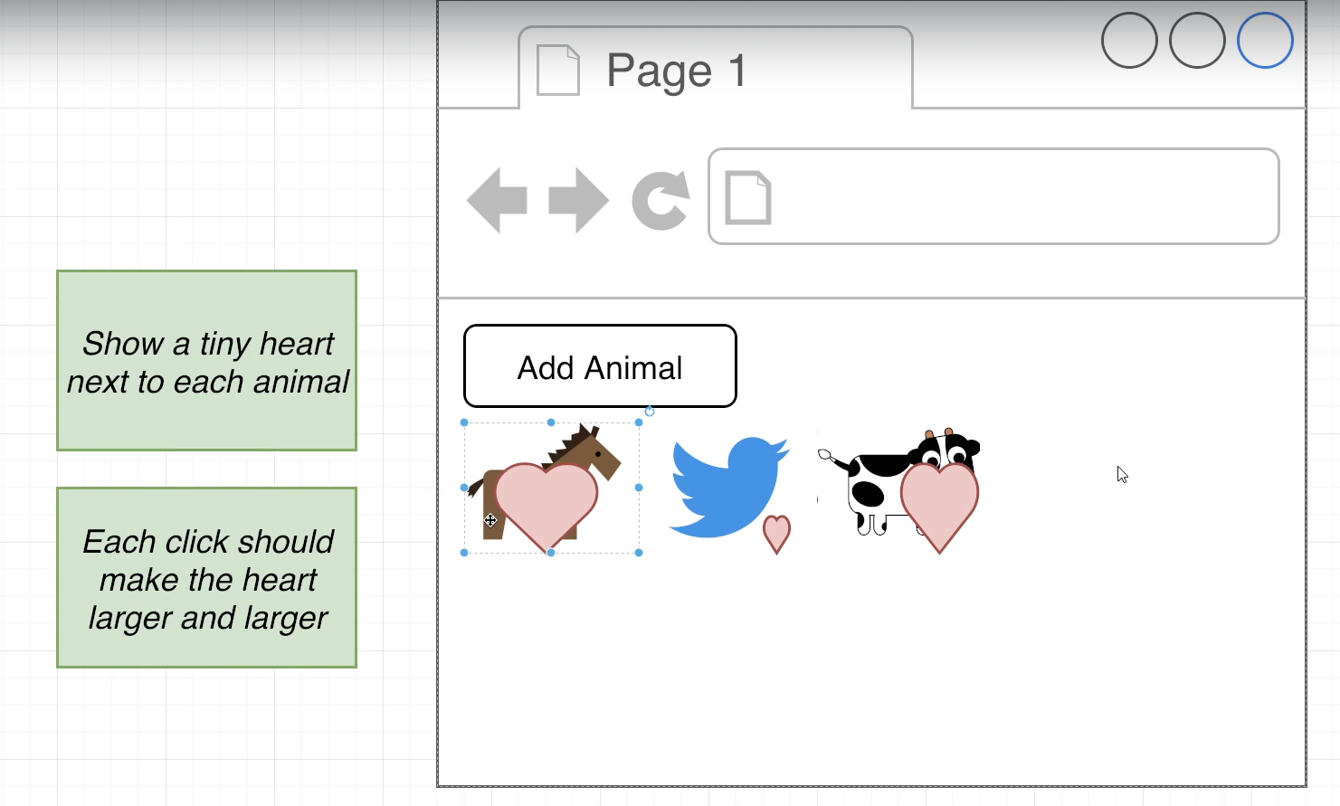

AnimalShow.js

import { useState } from "react";

import bird from "./svg/bird.svg";

import cat from "./svg/cat.svg";

import cow from "./svg/cow.svg";

import dog from "./svg/dog.svg";

import gator from "./svg/gator.svg";

import heart from "./svg/heart.svg";

import horse from "./svg/horse.svg";

const svgMap = {

  bird,

  cat,

  cow,

  dog,

  gator,

  horse,

};

function AnimalShow({ type }) {

    const [clicks, setClicks] = useState(0);

  function handleClick() {

     setClicks(clicks + 1);

  }

  return (

    <div onClick={handleClick}>

      <img alt="animal" src={svgMap[type]} />

      <img

        alt="heart"

        src={heart}

        style={{width: 10 + 10 * clicks + 'px'}}

      />

    </div>

  );

}

export default AnimalShow;

## 56. Adding Custom CSS

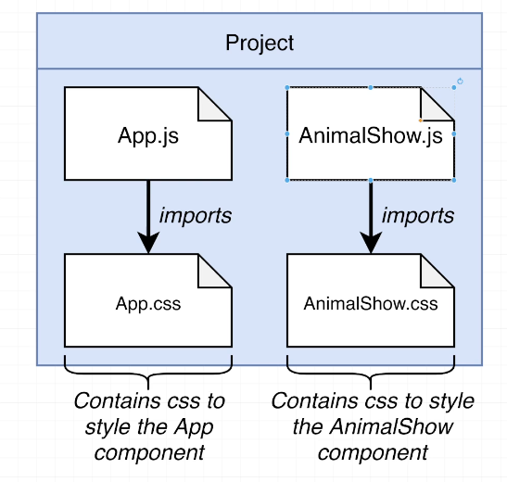

## 57. Finalizing Styling

AnimalShow.js

import './AnimalShow.css';

import { useState } from "react";

import bird from "./svg/bird.svg";

import cat from "./svg/cat.svg";

import cow from "./svg/cow.svg";

import dog from "./svg/dog.svg";

import gator from "./svg/gator.svg";

import heart from "./svg/heart.svg";

import horse from "./svg/horse.svg";

const svgMap = {

  bird,

  cat,

  cow,

  dog,

  gator,

  horse,

};

function AnimalShow({ type }) {

    const [clicks, setClicks] = useState(0);

  function handleClick() {

     setClicks(clicks + 1);

  }

  return (

    <div className="animal-show" onClick={handleClick}>

      <img className='animal' alt="animal" src={svgMap[type]} />

      <img className='heart'

        alt="heart"

        src={heart}

        style={{width: 10 + 10 * clicks + 'px'}}

      />

    </div>

  );

}

export default AnimalShow;

App.js

import "./App.css";

import { useState } from "react";

import AnimalShow from "./AnimalShow";

function getRandomAnimal() {

  const animals = ["bird", "cat", "cow", "dog", "gator", "horse"];

  return animals[Math.floor(Math.random() * animals.length)];

}

function App() {

  const [animals, setAnimals] = useState([]);

  const handleClick = () => {

     setAnimals([...animals, getRandomAnimal()]);

  };

  const renderedAnimals = animals.map((animal, index) => {

    return <AnimalShow key={index} type={animal} />

  })

  return (

    <div className="app">

      <button onClick={handleClick}>Add Animal</button>

      <div className="animal-list">{renderedAnimals}</div>

    </div>

  );

}

export default App;

## 58. App Wrapup and Review

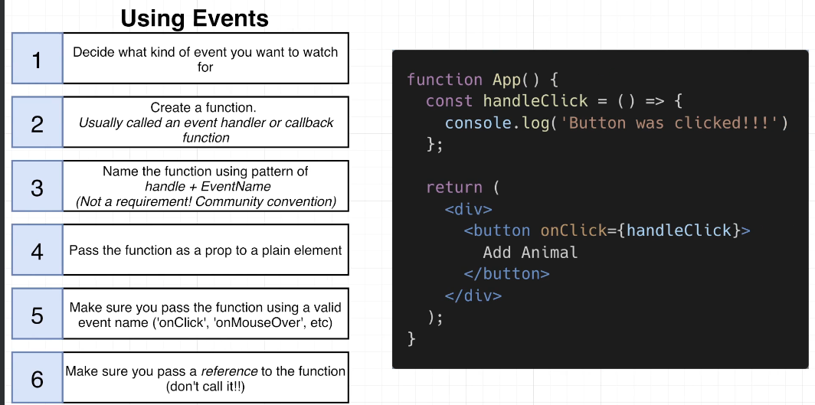

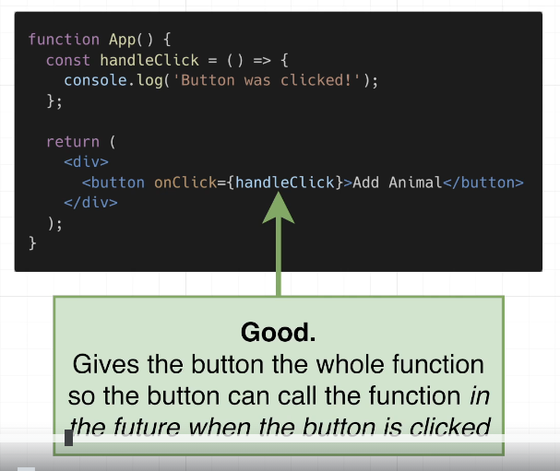

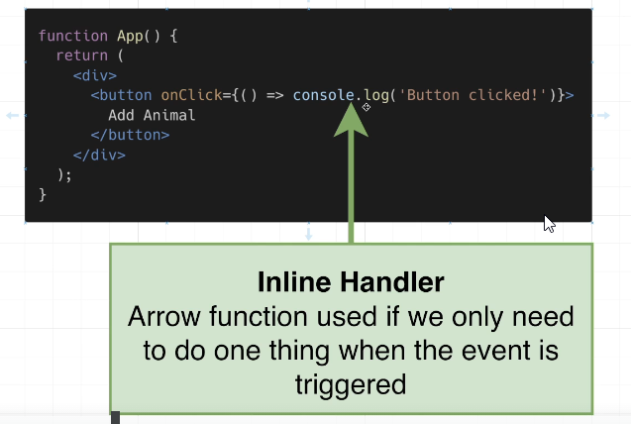

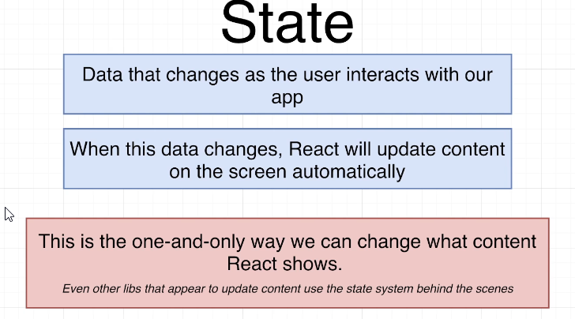

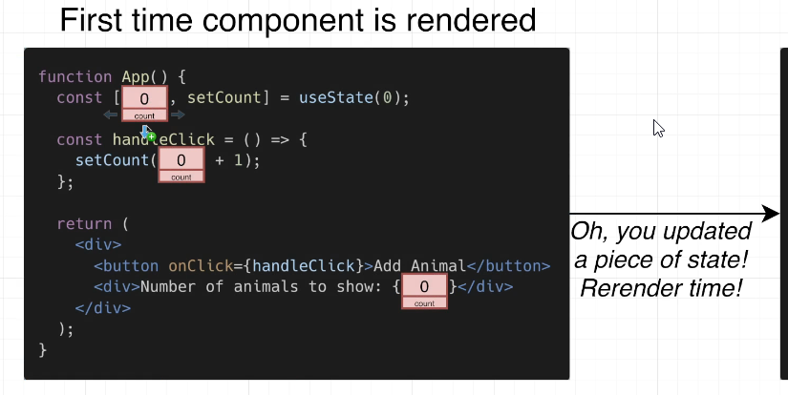

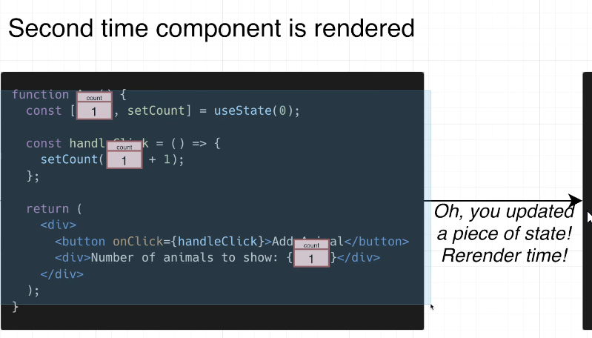

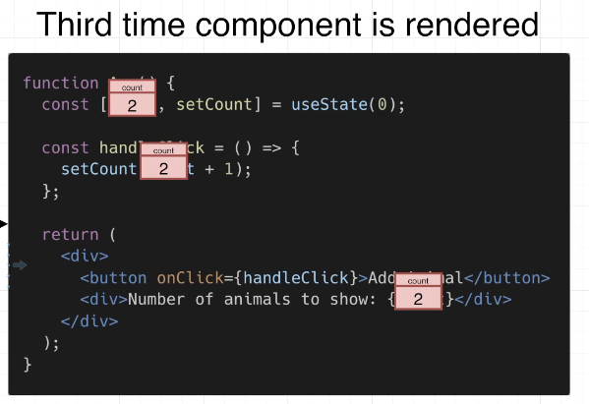

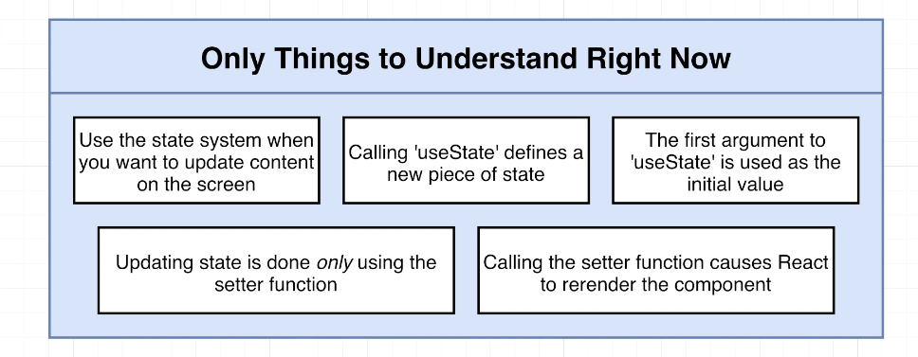

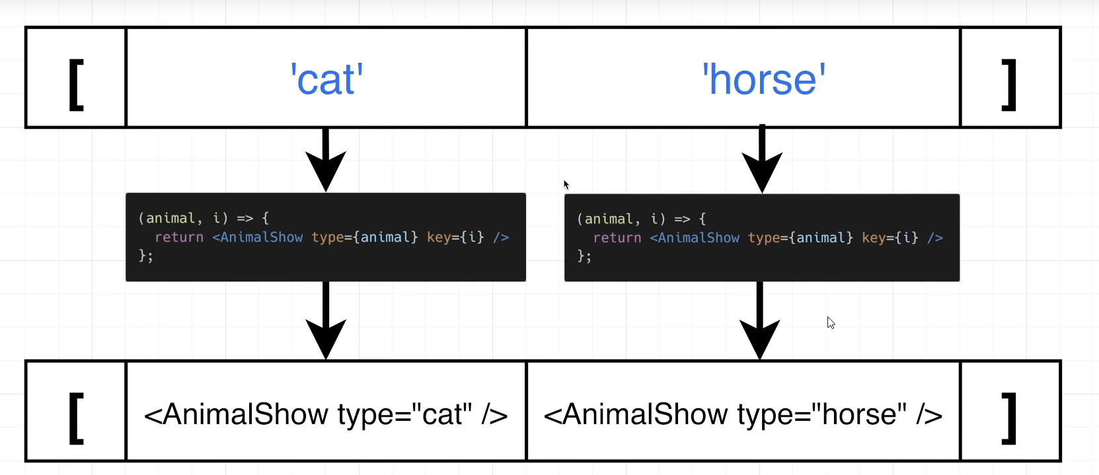

# Section 5: Using an API with React

## 59. App Overview

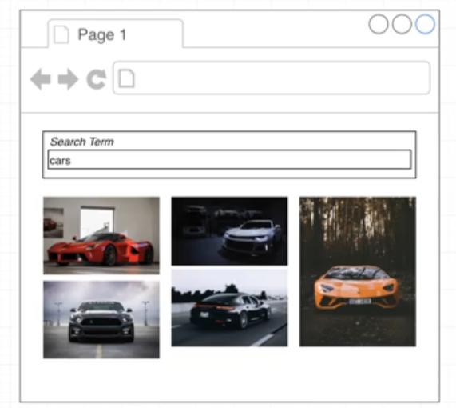

npx create-react-app 04pics

cd 04pics

npm start

## 60. Project Setup

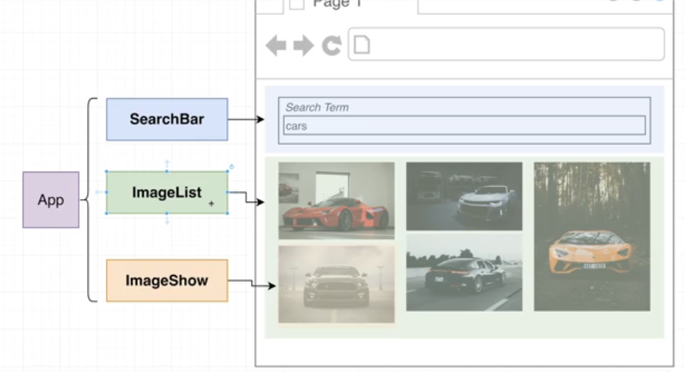

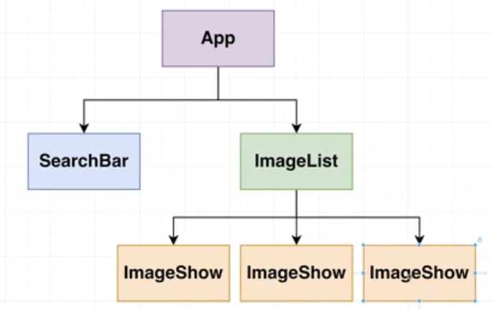

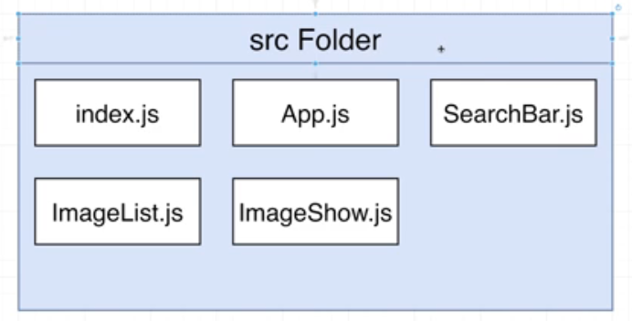

## 61. The Path Forward

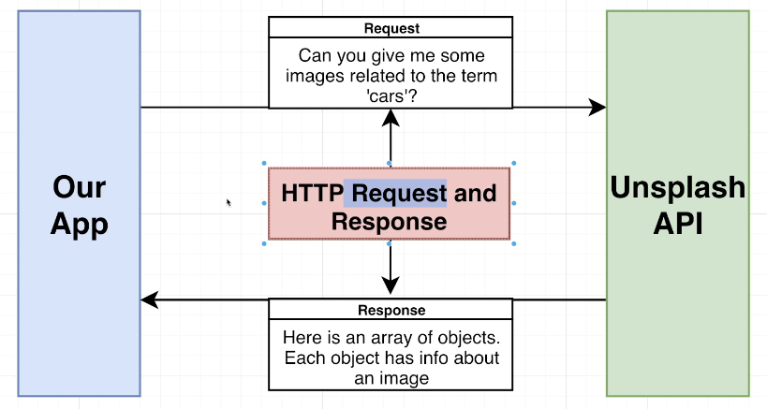

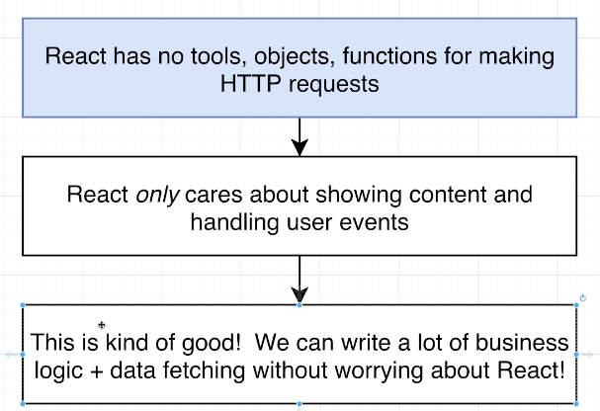

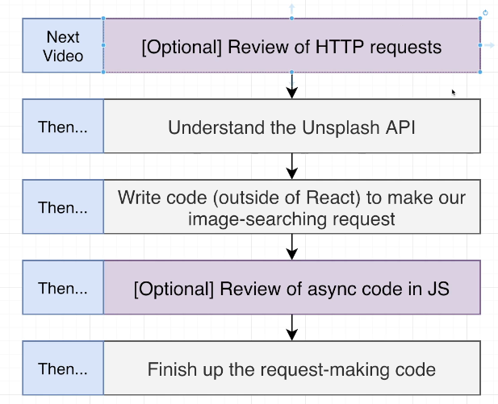

## 62. Overview of HTTP Requests

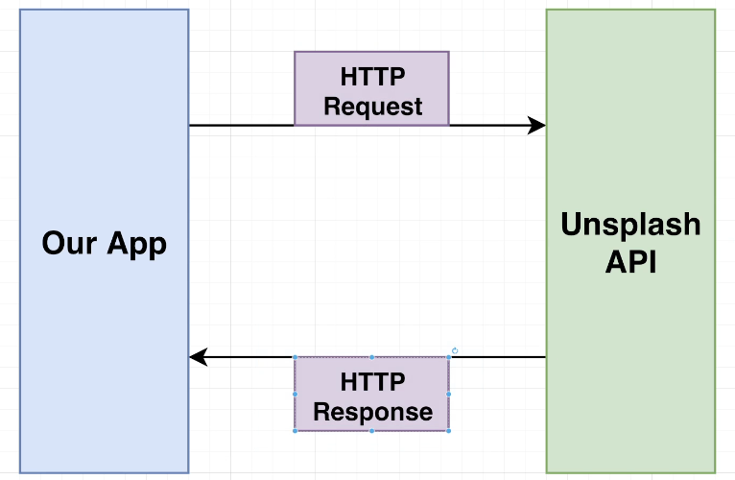

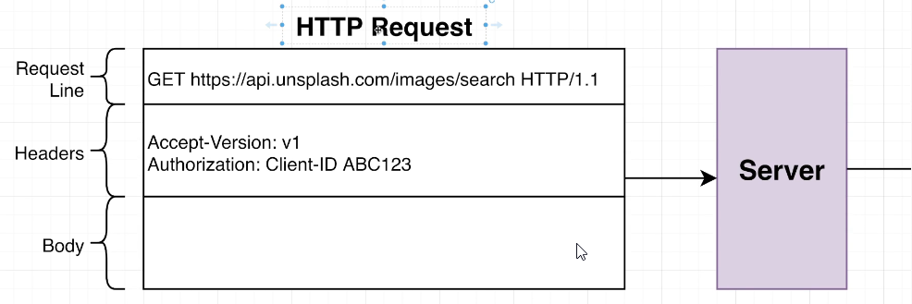

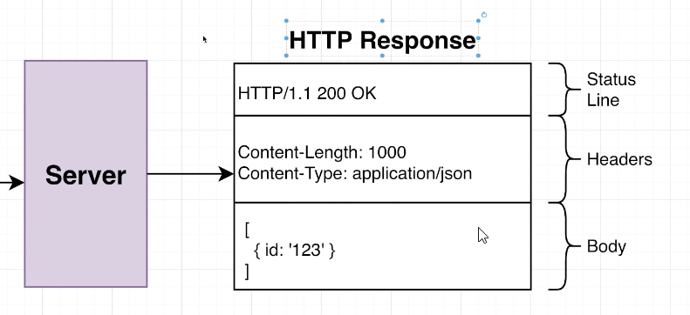

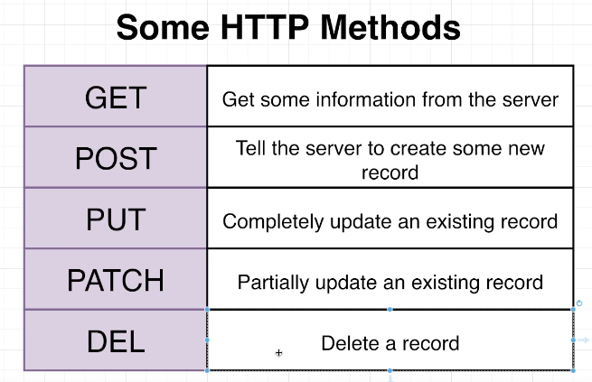

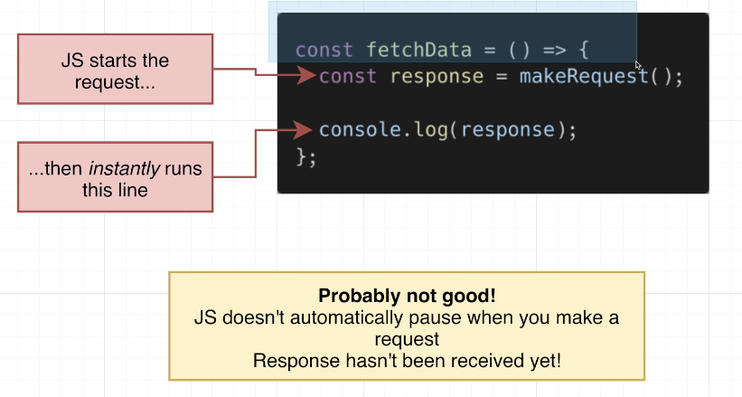

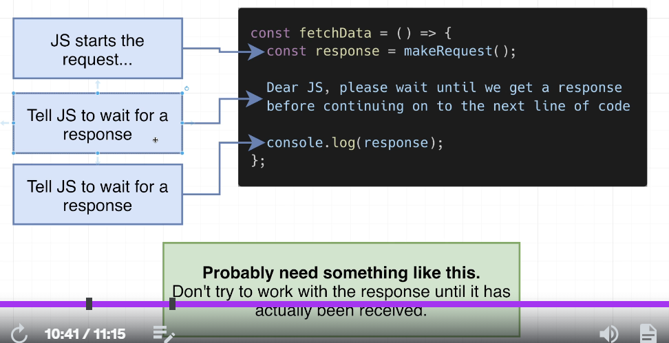

## 63. Understanding the API

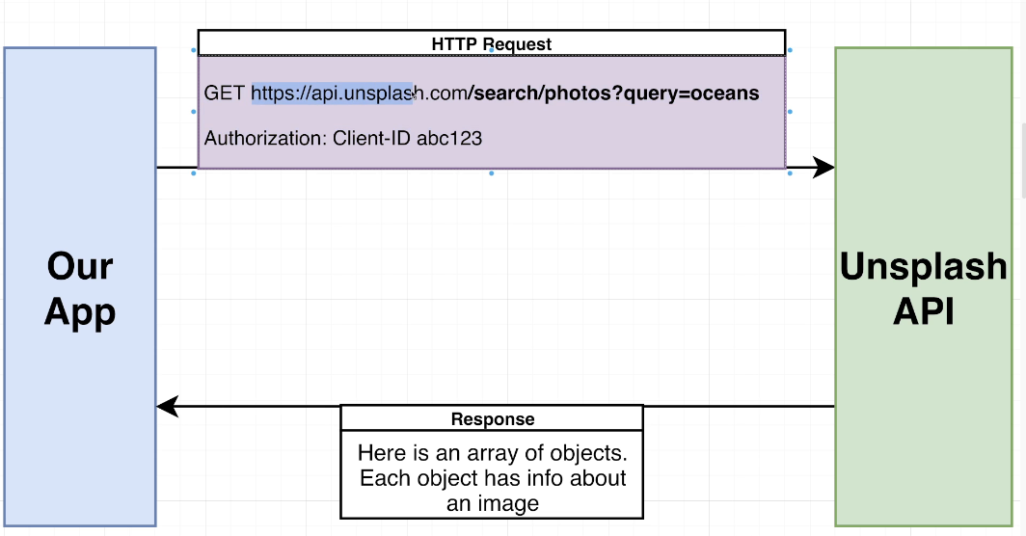

## 64. Making an HTTP Request

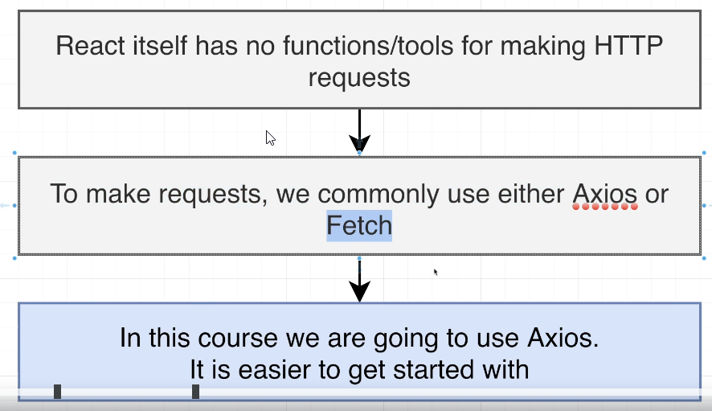

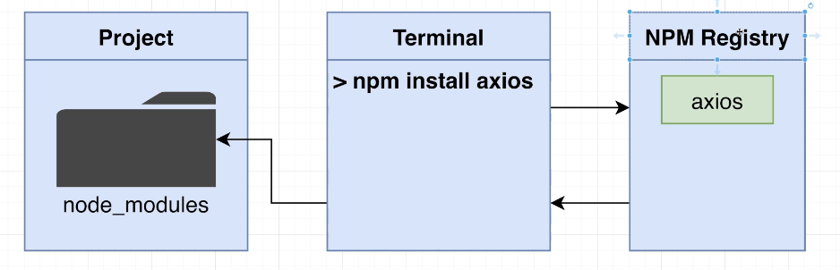

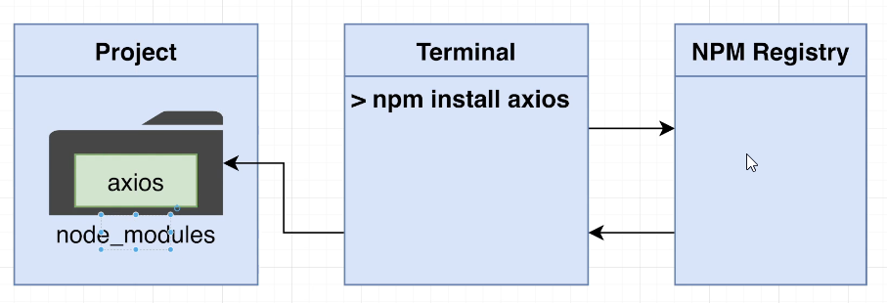

npm install axios

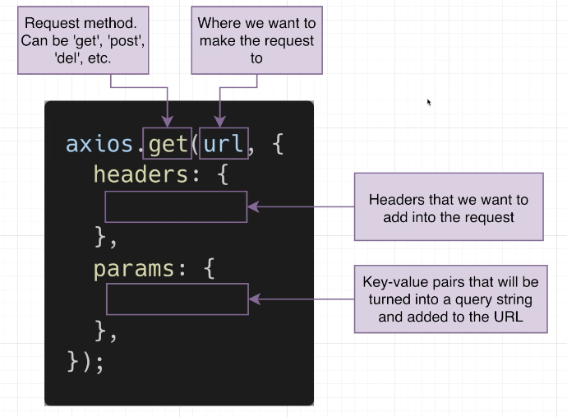

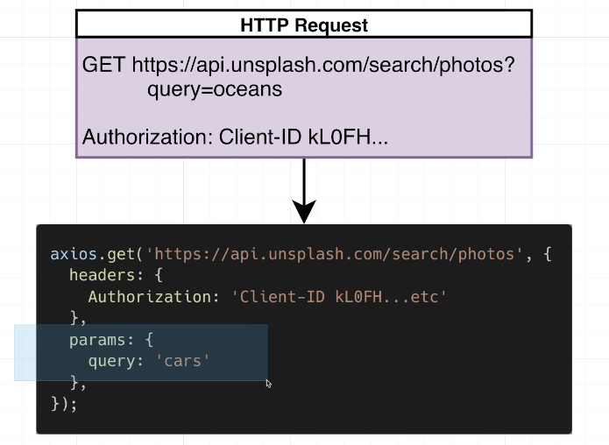

api.js

import axios from "axios";

const searchImages = async () => {

  const response = await axios.get("https://api.unsplash.com/search/photos", {

    headers: {

      Authorization:

        "Client-ID dba28937347d88249d994981b554ecc4d4b2b770ade79a0419adcb2823f744e4",

    },

    params: {

      query: "cars",

    },

  });

  console.log('response', response);

  return response

};

export default searchImages;

## 65. [Optional] Using Async:Await

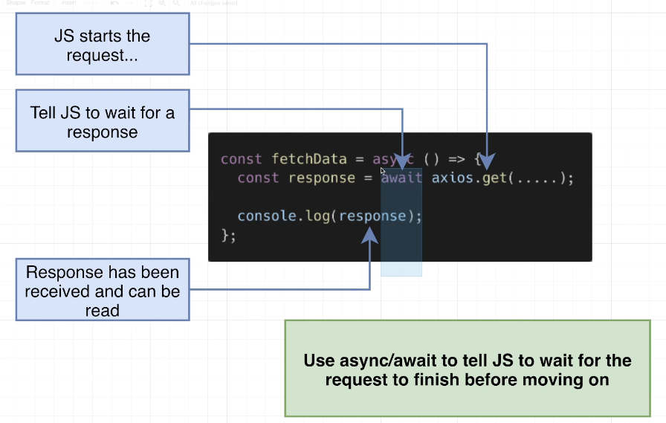

## 66. Data Fetching Cleanup

Api.js

import axios from "axios";

const searchImages = async (term) => {

  const response = await axios.get("https://api.unsplash.com/search/photos", {

    headers: {

      Authorization:

        "Client-ID dba28937347d88249d994981b554ecc4d4b2b770ade79a0419adcb2823f744e4",

    },

    params: {

      query: term,

    },

  });

  return response.data.results;

};

export default searchImages;

## 67. Thinking About Data Flow

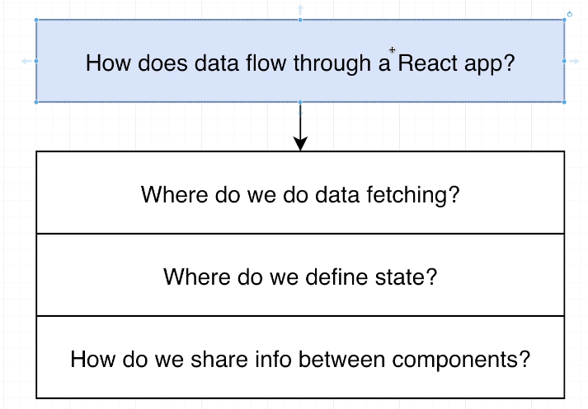

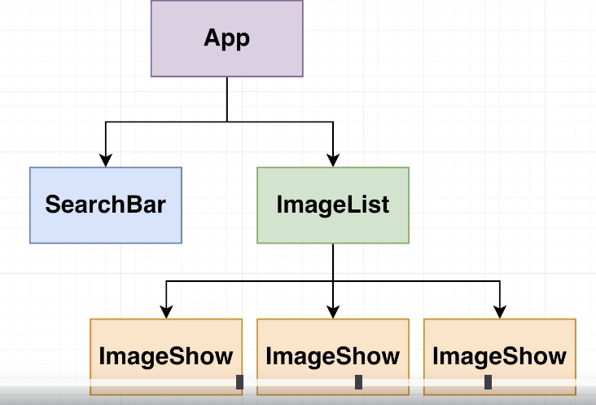 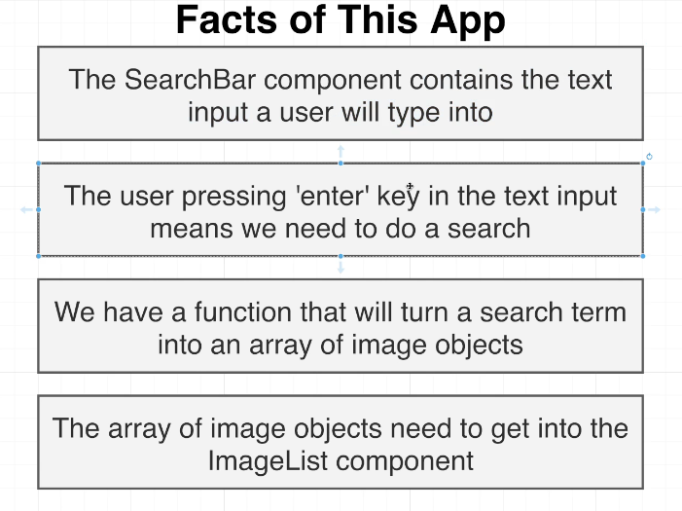

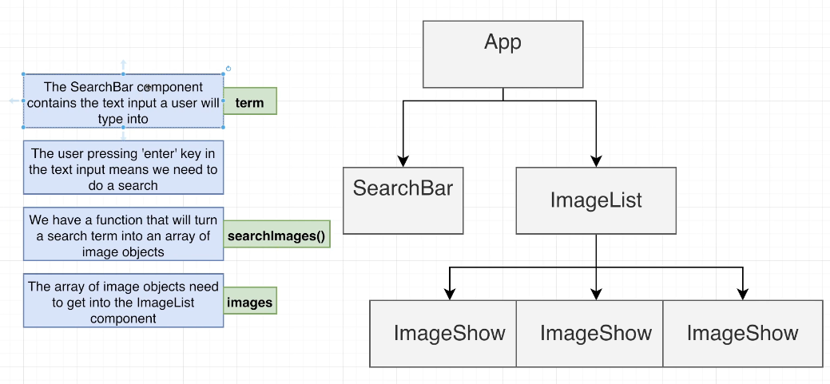

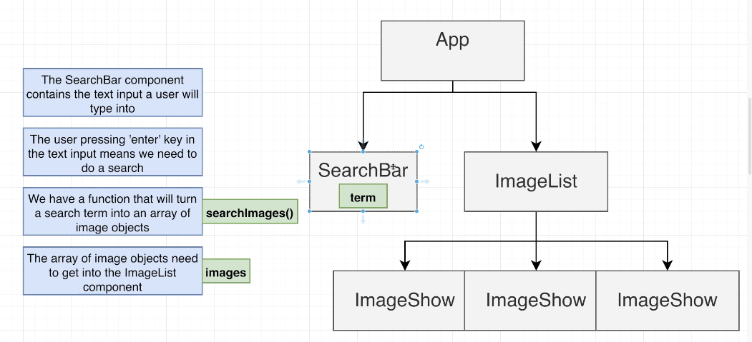

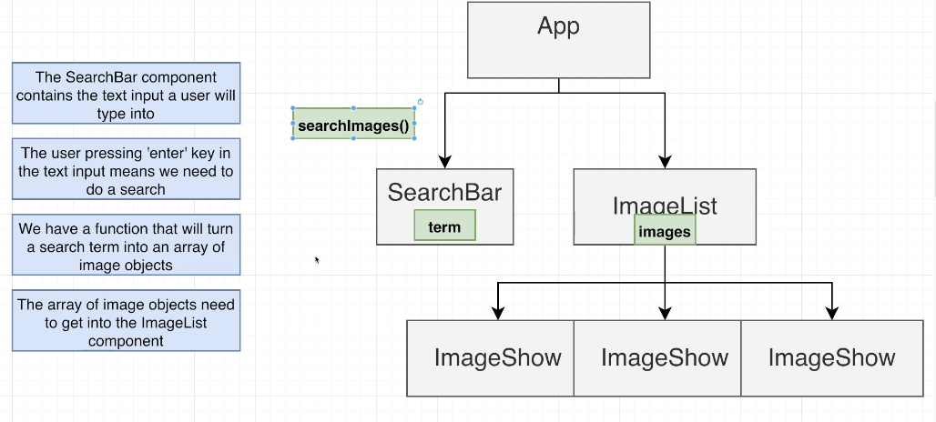

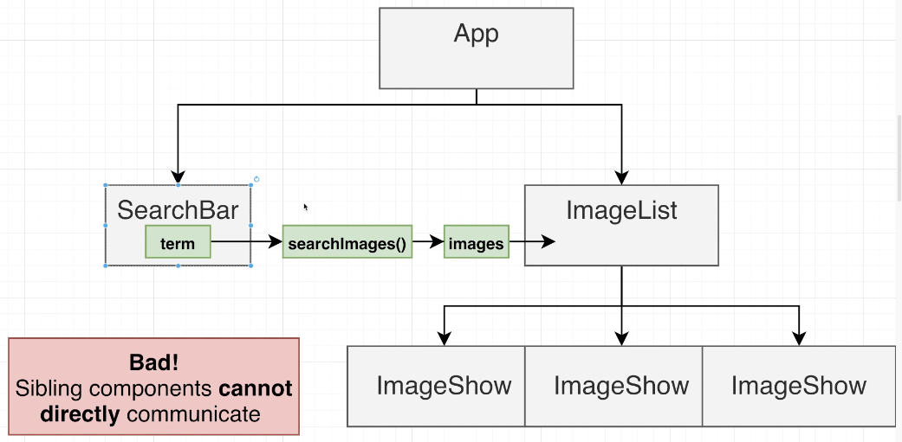

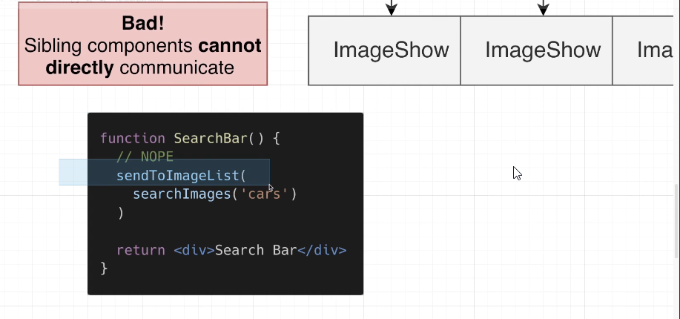

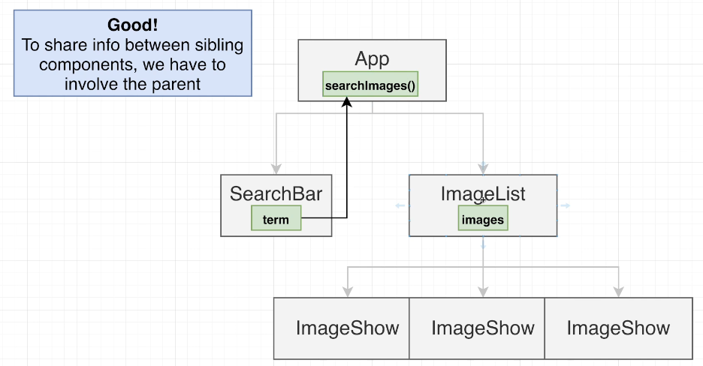

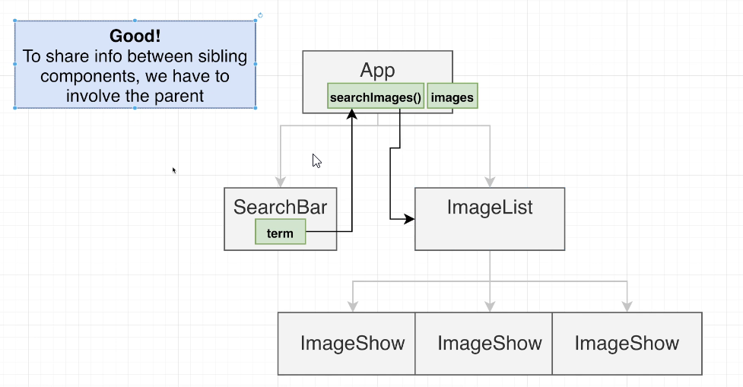

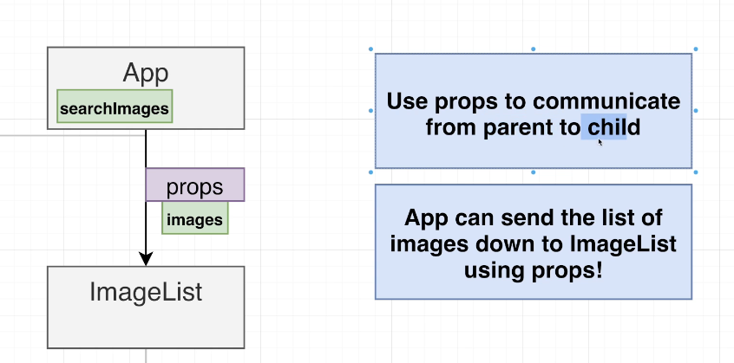

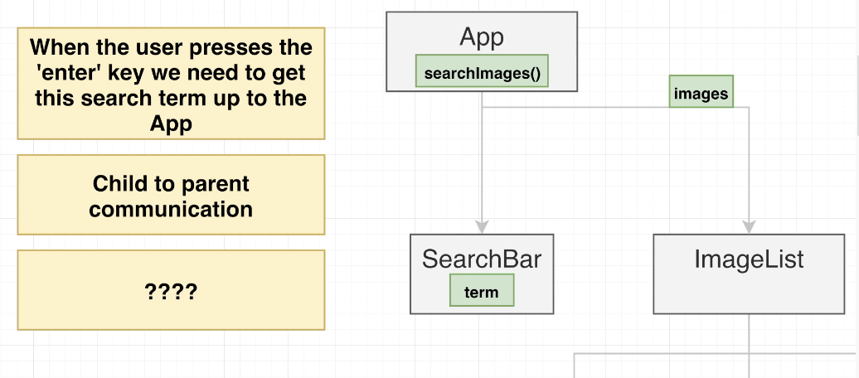

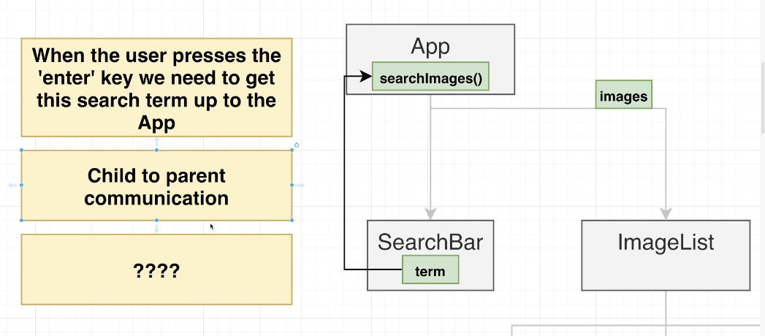

## 68. Child to Parent Communication

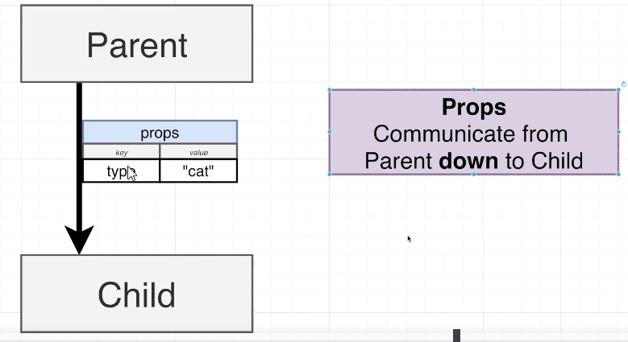

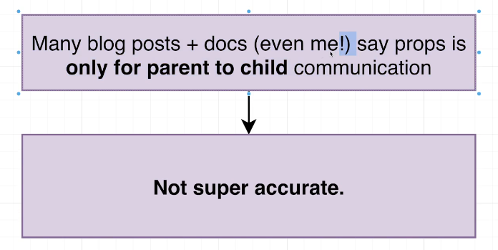

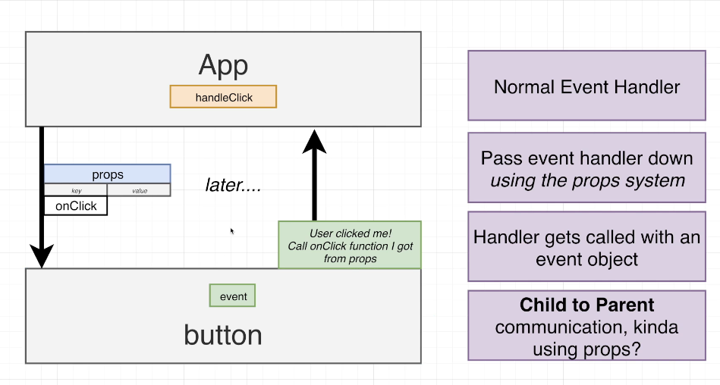

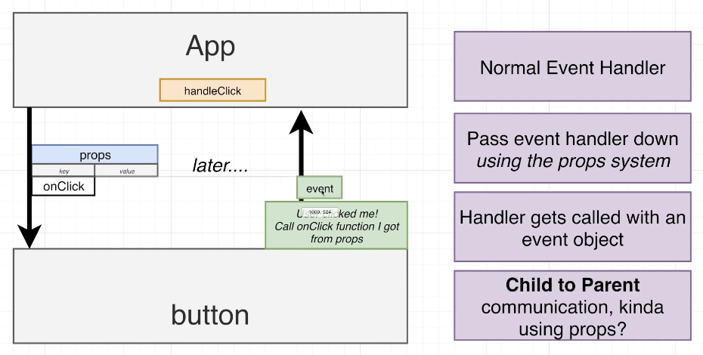

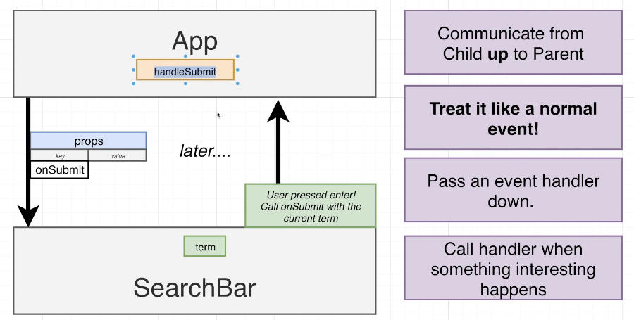

## 69. Implementing Child to Parent Communication

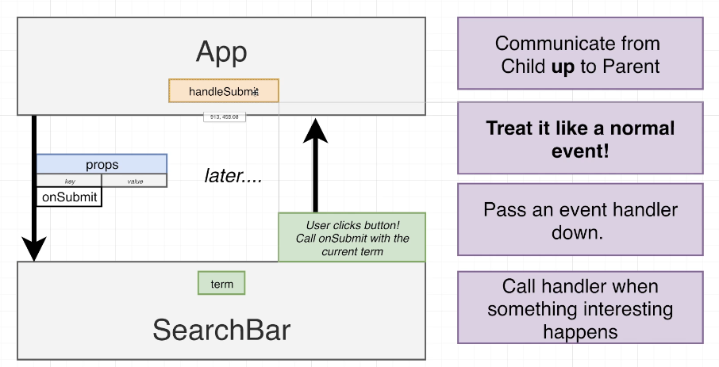

## 70. Handling Form Submission

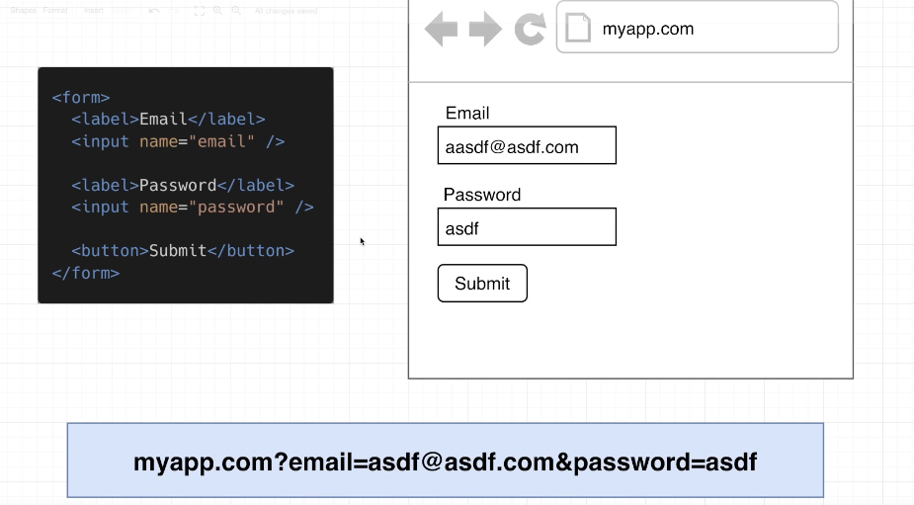

## 71. Handling Input Elements

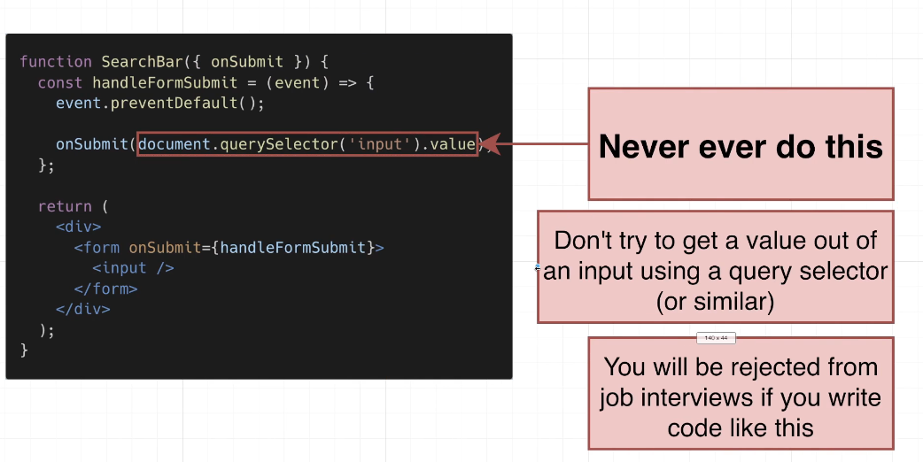

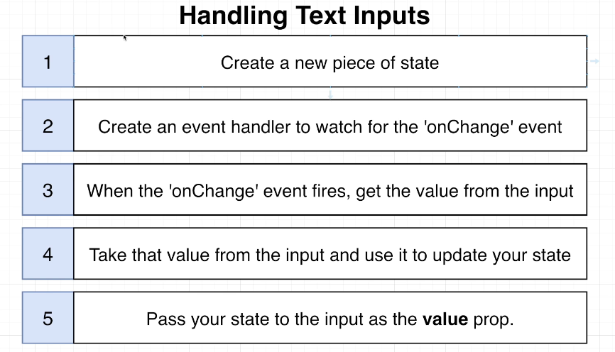

## 72. [Optional] OK But Why?

## 73. Exercise Solution

## 74. Running the Search

## 75. Reminder on Async:Await

## 76. Communicating the List of Images Down

## 77. Building a List of Images

## 78. Handling List Updates

## 79. Notes on Keys

## 80. Displaying Images

## 81. A Touch of Styling

## 82. App Wrapup